***https://doi.org/10.23913/ride.v13i26.1526***

***Artículos científicos***

**Modelado matemático de un colector solar fotovoltaico-térmico híbrido para evaluación del desempeño térmico en Cd. Juárez Chihuahua**

***Mathematical modeling of a hybrid photovoltaic-thermal solar collector to thermal performance evaluation at Cd. Juarez Chihuahua***

***Modelagem matemática de um coletor solar híbrido fotovoltaico-térmico para avaliação do desempenho térmico em Cd. Juárez Chihuahua***

**Jeovany Rafael Rodriguez Mejia**

Tecnológico Nacional de México, Campus Ciudad Juárez, México

jrodriguez@itcj.edu.mx

https://orcid.org/0000-0003-4154-0778

**Arturo Woocay Prieto**

Tecnológico Nacional de México, Campus Ciudad Juárez, México

awoocay@itcj.edu.mx

https://orcid.org/0000-0001-9235-0494

**Alfonso López Martínez**

Universidad Autónoma de Zacatecas, México

alopez2601@hotmail.com

https://orcid.org/0000-0001-8547-9468

**Ulises Martínez Contreras**

Tecnológico Nacional de México, Campus Ciudad Juárez, México

ulises.mc@itcj.edu.mx

https://orcid.org/0000-0002-1631-4448

**Adán Valles Chávez**

Tecnológico Nacional de México, Campus Ciudad Juárez, México

avalles@itcj.edu.mx

https://orcid.org/0000-0002-6559-0123

**Resumen**En la actualidad, el estudio de modelos de simulación de sistemas híbridos de energía ha ido en aumento debido a que, entre las fuentes de energía renovables, el sol es considerado uno de los de mayor potencial. Esta situación hace que sea más prometedor para nosotros estudiar la modelización de sistemas basados ​​en energía solar y sus aplicaciones de referencia. Utilizando modelos de simulación en aplicaciones de energía solar, es posible diseñar sistemas híbridos más complejos y eficientes evaluando su comportamiento en función de la energía entrante. Este documento muestra la modelización matemática de un sistema fotovoltaico térmico híbrido donde se evalúa el comportamiento energético del sistema, con la finalidad de incrementar la eficiencia de la célula fotovoltaica mediante el uso de un sistema de captación de calor residual. El modelo de simulación integra un modelo de célula fotovoltaica simple acoplado a un modelo de colector solar simple donde se ingresan los parámetros iniciales del sistema híbrido y sus diversas variables de control. Así, es posible estimar la generación de energía térmica y eléctrica a través de una simulación basada en el tiempo. Finalmente, para evaluar la sensibilidad del modelo, se consideran varios escenarios modificando el caudal y la temperatura del fluido en la entrada para comparar el comportamiento energético del sistema híbrido.

**Palabras Clave:** Sistemas PVT; Energía Solar; Celdas Fotovoltaicas; Sistemas Híbridos; Cogeneración; Energía Renovable.

**Abstract**

Nowadays, the study of simulation models of hybrid energy systems has been increasing due to the fact that, among renewable energy sources, the sun is considered one of the highest potential. This situation makes it more promising for us to study the modeling of systems based on solar energy and its reference applications. Using simulation models in solar energy applications, it is possible to design more complex and efficient hybrid systems by evaluating their behavior as a function of incoming energy. This document shows the mathematical modeling of a hybrid thermal photovoltaic system where the energy behavior of the system is evaluated, with the purpose of increasing the efficiency of the photovoltaic cell by using a residual heat capture system. The simulation model integrates a simple photovoltaic cell model coupled to a simple solar collector model where the initial parameters of the hybrid system and its various control variables are entered. Thus, it is possible to estimate the generation of thermal and electrical energy through a time-based simulation. Finally, to evaluate the sensitivity of the model, various scenarios are considered by modifying the flow rate and temperature of the fluid at the inlet to compare the energy behavior of the hybrid system.

**Keywords:** PVT-Systems; Solar Energy; PV-Cell; Hybrid Systems; Cogeneration; Renewable Energy**.**

**Resumo**

Atualmente, o estudo de modelos de simulação de sistemas híbridos de energia vem aumentando, pois, dentre as fontes renováveis ​​de energia, o sol é considerado uma das de maior potencial. Esta situação torna mais promissor para nós estudar a modelagem de sistemas baseados em energia solar e suas aplicações de referência. Usando modelos de simulação em aplicações de energia solar, é possível projetar sistemas híbridos mais complexos e eficientes, avaliando seu comportamento em função da energia recebida. Este documento mostra a modelagem matemática de um sistema fotovoltaico térmico híbrido onde o comportamento energético do sistema é avaliado, a fim de aumentar a eficiência da célula fotovoltaica através do uso de um sistema de coleta de calor residual. O modelo de simulação integra um modelo simples de célula fotovoltaica acoplado a um modelo simples de coletor solar onde são inseridos os parâmetros iniciais do sistema híbrido e suas diversas variáveis ​​de controle. Assim, é possível estimar a geração de energia térmica e elétrica por meio de uma simulação baseada no tempo. Finalmente, para avaliar a sensibilidade do modelo, vários cenários são considerados, modificando a vazão e a temperatura do fluido na entrada para comparar o comportamento energético do sistema híbrido.

**Palavras-chave:** Sistemas PVT; Energia solar; Células fotovoltaicas; Sistemas Híbridos; cogeração; Energia renovável.

**Fecha Recepción:** Junio 2022 **Fecha Aceptación:** Enero 2023

**Introduction**

The development of energy generation and cogeneration devices through renewable energy resources has been increasing, due to the effects generated by using fossil fuels to generate electrical energy or heat mainly. The greatest effect of the use of non-renewable energy resources is global warming, in addition to its gradual exhaustion. Under this premise, it is considered that solar energy is the one with the greatest impact at present and generates the greatest benefit to humanity due to its minimal damage to the environment, being free in addition to its availability. For this reason, the study of new hybrid energy generation systems is of great importance, mainly based on renewable energy resources, where the most significant so far is the use of solar energy as a primary source.

The significant advantage of solar energy is that its conversion is direct, although so far it is not very efficient; For example, photovoltaic energy converts solar energy into electricity due to the photovoltaic effect, but with a yield of no more than 25%, or in its case, solar thermal energy that converts solar energy into thermal energy due to the absorption capacity and mechanisms of heat transfer developed in the system that also have a performance of up to 75%. It is also possible to have cogeneration systems that increase their overall performance, by combining photovoltaic and solar thermal, up to 85%. It is for this reason that governments together with the International Renewable Energy Agency (IRENA) have developed a vision perspective for 2050 with the purpose of achieving at least an 86% participation in electricity generation with renewable energies, (IRENA,2019). Mexico regarding the use of solar energy does not exceed 2% of participation for the production of electrical energy, unlike 79% from fossil fuels, (IRENA,2015), (SENER, 2018). Therefore, it is necessary to increase the active use of alternative energy to produce electrical energy, and thus take advantage of the country’s solar potential since it can be considered one of the most promising renewable energy sources, mainly due to its easy access.

The development of energy generation and cogeneration devices depends on the quality of solar energy and on design parameters. So, by optimizing the design parameters it is possible to increase its efficiency, durability, reliability, as well as the safety aspects and competitive costs. For this reason, this work integrates a mathematical simulation model that allows a quantitative and qualitative analysis of a thermal photovoltaic hybrid system and a sensitivity analysis of the system design parameters.

Applications of solar energy have been studied extensively, particularly those of direct conversion, such as solar thermal and photovoltaic (Ramos, G. L., 2012), (Wu Y., Wu S., and Xiao L., 2017), (Apatekar, S., & Mallareddy, Ch., 2015), (Syafiqah Z., Irwan YM., Amin N., Irwanto M., Leow WZ. and Amelia AR., 2017). Most of the studies based on photovoltaic cells have been directed towards the modeling and simulation of equivalent circuits such as the simple diode, in order to analyze the influence of solar radiation, cell temperature, and weather conditions on the behavior of the photovoltaic module in stationary or dynamic state, as is showed in, (Amelia A.R., Irwan Y.M., Leow W.Z., Irwanto M., Safwati I., Zhafarina M., 2016), (Belhadj, C., Kassas, M., & Essamuddin, S., 2015), (Desisaa D. G., Shekatab G. D., 2020).

Jangwoo, P., Hong-geun, K., Yongyun, C., & Changsun, S., (2014) studied the mathematical modeling of a photovoltaic cell using equivalent circuits that include the effects of solar radiation, operating temperature, as well as some module construction parameters. The model is developed in MatLab / Simulink using maximum power point techniques. Another important parameter in the study of photovoltaic modules is the temperature response with respect to the change in incident radiation, which is considered dynamic and cannot be analyzed in detail in a stationary model. For this reason, various stationary and dynamic models have been studied to determine said time constant, in addition to the effects that cell temperature causes on energy conversion, as well as the non-linearities of the system, as is showed in (Armstrong, S., & Hurley, W. G., 2010), (Sadeghzadeh, M., Ahmadi, M. H., Kahani, M., Sakhaeinia, H., Chaji, H., & Chen, L., 2019), (Patel G. A., 2016), (Manjunath, M. S., Karanth, K. V., & Sharma, N. Y., 2018), (Libra M., Poulek V., Kouřím P., 2017), (Yeshalem M. T. and Khan B., 2017), (Singh, A. P., & Singh, O. P., 2018).

Another case study is that of solar water heaters, which for several decades ago have been exhaustively analyzed by researchers, and currently it has been possible to have a maturity in effective knowledge about the various models, their applications and in general greater reference is made to the flat plate, mainly due to the simplicity in developing its energy analysis (Armstrong, P., 1978). Numerical analyses of the behavior of the solar collector based on heat transfer and energy balance have been performed, as is showed in, (Paz, G. J. C., 2005), (SOLARTRONIC, 2003). Taking these analyses as a basis, mathematical models of hybrid systems called photovoltaic-thermal based on water or air have been developed. These hybrid systems are considered more thermally efficient, since a photovoltaic cell loses efficiency by increasing its operating temperature, and a solar collector can become a heat sink for the cell when combined. These types of devices are called cogeneration systems, since at the same time they generate electrical and thermal energy depending on the same energy source. It also allows the energy conversion mechanism to be more efficient in both cases (Chow, T. T., Tiwari, G. N., & Menezo, C., 2012), (Preet S., Bhushan B., Mahajan T., 2017).

The configurations developed for this cogeneration system may depend on the type of working fluid, geometry, heat transfer mechanism, materials, among other constructive characteristics. In thermal photovoltaic-cogeneration systems based on water, thermal efficiency ranges of 45% to 70% have been reached, as is showed in (Jin H. J., Kadi I., Barth T., and Leszczynski E., 2017), (Stropnik R., Stritih U., 2016). This has served to understand that the effect of temperature on photovoltaic modules reaches a relative decrease in efficiency of up to 15% if the temperature increases a range of 30 K, as is enounced in, (Kasaeiana A., Khanjaria Y., Golzaria S., Mahian O., and Wongwises S., 2017), (Kazemiana A., Salarib A., Hakkaki-Fard A. and Maa T., 2019), (Khanjari Y., Pourfayaz F., and Kasaeian A.B., 2016).

In order to analyze this type of hybrid photovoltaic-thermal energy cogeneration systems, this work develops a mathematical model of a hybrid photovoltaic-thermal collector based on the mechanisms of heat transfer and energy balance in a quasi-stable state. This model allows simulating the energy behavior of the hybrid system, taking solar radiation, ambient temperature, and wind speed as a function of time as input. It also allows considering the independent modeling of a flat plate solar collector and a single diode equivalent circuit to simulate the behavior of the photovoltaic cell. The simulation model is carried out in MatLab and allows analyzing the operating characteristic curves of the cell, solar collector, and hybrid system. cooperation.

**Materials and Methods**

**Hybrid system model**

The system that was developed for this work consists of the assembly of a photovoltaic cell with an absorber plate, which allows the photovoltaic module to be cooled through the passage of a fluid flow. This work describes the mathematical model of the hybrid photovoltaic cell collector system, which allows evaluating the thermal and electrical behavior of the hybrid system. Furthermore, the same model allows the sensitivity of the system to be analyzed according to the working fluid and the geometry of the absorber plate.

The mathematical model was developed from an energy balance considering the first law of thermodynamics, as well as the correlation of heat transfer mechanisms in the steady state system. The hybrid system has as fixed input the intensity of the solar radiation with respect to the inclination plane, the ambient temperature surrounding the system, and the average wind speed of the surrounding medium. In addition to the fixed inlets, it is possible to consider as input the flow rate of the fluid passing through the collector, the geometry of the system and the positioning with respect to the horizontal. Then the main outputs of the system are the electrical power produced, and the heat absorbed by the plate through the fluid. But as output it is also possible to consider the temperature of the photovoltaic cell, the temperature of the water at the outlet of the collector.

The mathematical model of the hybrid system is described generally through an analogy of thermal resistances. The first energy balance is carried out in the photovoltaic module. Here it is considered that the incoming energy is the effective solar radiation ${q"}_{s}$, and the outgoing energy is the effective electric power ${q"}_{ele}$, heat lost by convection is ${q"}_{conv}$, heat lost by radiation is ${q"}_{rad}$ and the residual heat of the photovoltaic system is ${q"}_{upv}$; where the units of the energy balance are given in unit of power by unit area. The Figure 1. shows the Hybrid System Mathematical Model like resistances and energy flows.

To adjust the model of the hybrid system, a linear model of the efficiency of the photovoltaic panel with respect to the cell temperature was developed. This model correlates the electrical efficiency of the solar module with the temperature reached by the cell under normal operating conditions in the solar plant of the solar energy laboratory of the Tecnologico Nacional de Mexico Campus Ciudad Juarez. This model is described in eq. 1 and in the same way in Figure 2.

$η_{e} = 0.2678 - 0.003 * T_{c}$ (1)

Then, the energy conservation model for the steady state photovoltaic cell is described in eq. 2.

${q"}_{s} = {q"}_{upv} + {q"}_{rad} + {q"}_{conv} + {q"}_{ele}$ (2)

where the effective solar radiation, described in eq. 3, depends of the transmittance $(τ)$ and the absorptance $(α)$ of the photovoltaic panel and the irradiance in the tilted plane $(G_{T})$.

${q"}_{s} = ταG_{T}$ (3)

heat loss by convection, described in eq. 4, depends on the convective coefficient $(h)$, ambient temperature $(T_{a})$ and cell temperature $(T_{c})$.

${q"}_{conv} = h(T_{c} - T_{a})$ (4)

**Figure 1**. Hybrid System Mathematical Model: a) Analog representation of hybrid system mathematical model in thermal resistances. b) Analog representation of hybrid system mathematical model in energy flows.

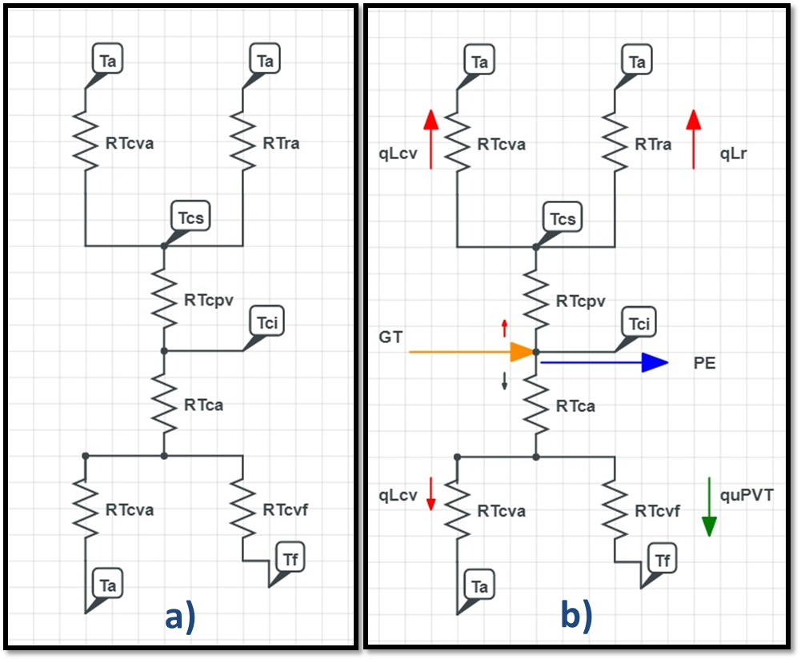

**Source**: Own.

heat losses due to radiation, described in eq. 5, depend on the Stefan-Boltzmann constant $(σ)$, emissivity of the photovoltaic module $(ε)$, ambient temperature $(T_{a})$ and cell temperature $(T_{c})$.

${q"}_{rad} = σε\left(T_{c}^{4} - T_{a}^{4} \right)$ (5)

where the effective electrical power, described in eq. 6, depends on the transmittance $(τ)$, absorptance $(α)$ and electrical efficiency of the photovoltaic panel $(η_{e})$, in addition to the irradiance in the inclination plane $(GT)$.

${q"}_{ele} = ταGTη_{e}$ (6)

The second energy balance is performed on the absorber plate considering that a residual heat ${q"}_{upv}$ is obtained from the photovoltaic panel, which is transferred to the fluid through a finned system type heat exchanger, better known as a flat plate collector. In particular, for this system it must be considered that in its development there is a heat removal factor $(Fr)$ and a minimum amount of energy losses by convection. Therefore, this system absorbs the residual heat from the photovoltaic module and is transferred to the fluid to have a useful process heat called ${q"}_{uPVT}$ as described in eq. 7.

${q"}_{uPVT}= Fr[{q"}_{upv} - U_{p}(T_{1} - T_{a})]$ (7)

where $(U_{p})$ is the overall heat transfer coefficient and $T_{1}$ is the inlet fluid temperature.

Finally, and in addition to this model, another equation is provided to adjust the cell temperature based on the estimation of the residual heat and the useful process possible to extract from the system and thus obtain the calculated cell temperature $(T_{cc})$ based on the proposed model, described in eq. 8.

$T_{cc}=\frac{{q"}_{upv}- {q"}_{uPVT}}{U_{p}}+T_{a}$ (8)

**Algorithm of simulation**

The model requires an iterative process for the adjustment and estimation of the parameters dependent on the cell temperature. It also requires the vectors and input parameters. Considering that they are two independent systems, but coupled to form one, the entire system will be co-dependent on the parameters of the photovoltaic module and solar collector. Therefore, the model must be powered with the input parameters and vectors of the photovoltaic panel, solar collector and solar energy.

In the case of the photovoltaic cell, the constructive parameters of the type of solar cell are required. In addition, the algorithm considers in its iteration the simple diode model of a photovoltaic cell to estimate its parameters and behavior as a function of radiation. The parameters that are estimated are generated current $(I)$, developed voltage $(V)$, electrical power $(P)$ and electrical efficiency $(η_{e})$. In a similar way, the model that establishes the characteristic parameters of the solar collector is embedded, that is, the coefficients of loss by convection, radiation, removal factor are estimated through the construction parameters and the overall heat transfer coefficient $(U_{p})$. Therefore, with these parameters it is possible to estimate the useful heat and thermal efficiency of the system.

**Figure 2**. Linear model of the efficiency of PV Cell with respect to the cell temperature.

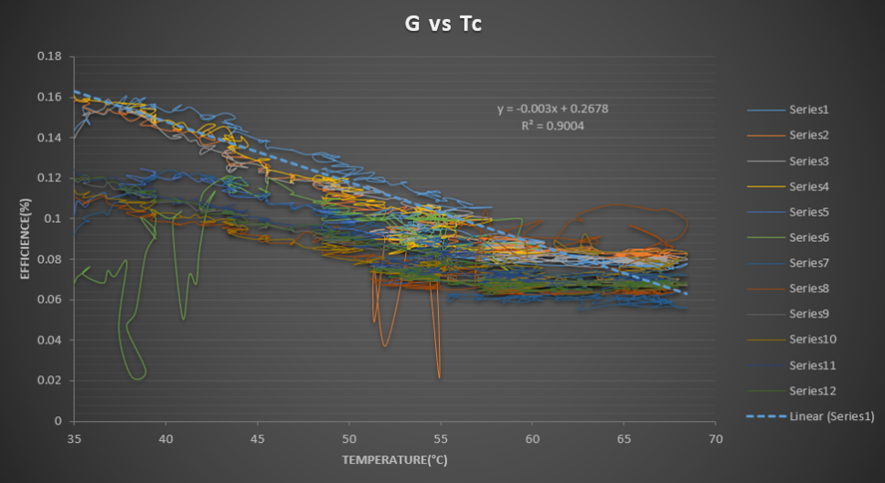

**Source**: Own.

For the analysis of the algorithm sensitivity, it is possible to modify the constructive parameters of the hybrid system, working fluid and input vectors such as irradiation and ambient temperature. At the entrance, some of the construction parameters related to the type of cell to be evaluated (polycrystalline or monocrystalline), solar collection area, temperature of the working fluid and rate of operating flow, which are entered by the user. After, we are using the algorithm of simulation of the mathematical model of the hybrid photovoltaic-thermal collector system to estimate the process of generate energy like electrical and heat. The thermal performance analysis of the hybrid system is obtained as a function of the heat absorbed by the collector, described in 9.

$η_{th}=\frac{{q"}_{uPVT}}{{q"}_{s}}$ (9)

Like the thermal performance estimated by the algorithm, the electrical performance of the cell, described in eq. 10, is obtained by adjusting the electrical efficiency of the photovoltaic panel itself, which is dependent on the temperature of the adjusted cell.

$η_{e,I I} = 0.2678 - 0.003 * T_{c}$ (10)

Finally, the overall performance $(η_{G})$ of the hybrid system, described in eq. 11, is obtained as the sum of the thermal and electrical efficiency.

$η_{G} = η_{th} + η_{e}$ (11)

The algorithm that evaluates the performance of the hybrid photovoltaic-thermal collector system is described through the following flow diagram as shown on Figure 3.

**Figure 3**. Flow diagram of algorithm of the hybrid photovoltaic-thermal collector system.

**Source**: Own.

**Results**

In the evaluation of the behavior of the mathematical model of the hybrid system, the steps described through the flow diagram are followed. Therefore, it is necessary to consider the two alternative algorithms which are described in Appendix A.

The first of them is the photovoltaic cell model based on a simple diode, in this case the analysis is considered through the NOCT parameters and constructive parameters of the photovoltaic cell, described in Table 1 and Table 2 respectively. Subsequently, the second model is evaluated, which is the flat plate collector, which simulates the absorption of residual heat from the photovoltaic cell, that is, the energy source ceases to be the sun and becomes the photovoltaic cell. For the analysis of this model, the construction parameters of the flat plate collector described in Table 3 are required.

**Table 1. Nominal Operating Cell Temperature Parameters.**

|  |  |
| --- | --- |
| Parameter | Value |
| $$T_{c,NOCT}$$ | $$45 °C$$ |
| $$T_{a,NOCT}$$ | $$20 °C$$ |
| $$G_{T,NOCT}$$ | $$800 W/m^{2}$$ |
| $$η_{c}$$ | $$0.19$$ |
| $$τ_{α}$$ | $$0.9$$ |

**Source**: Sun. V, (2020).

**Table 2. Photovoltaic Cell Parameters Model SAYA-P130-28.**

|  |  |  |  |
| --- | --- | --- | --- |
| Parameter | Value | Parameter | Value |
| $P_{mp}$ | $$129.42 W$$ | $G_{ref}$ | $$1000 W/m^{2}$$ |
| $I_{mp}$ | $$8.254 A$$ | $T_{c,ref}$ | $$298 K$$ |
| $V_{mp}$ | $$15.68 V$$ | $AM$ | $$1.5$$ |
| $I_{sc}$ | $$9.12 A$$ | $µ_{sc}$ | $$0.00053 A/K$$ |
| $V_{oc}$ | $$18.23 V$$ | $κ$ | $$1.381e^{-23} J/K$$ |
| $N_{c}$ | $$28$$ | $q$ | $$1.602e^{-19} C$$ |
| $A$ | $$1.3$$ | $eg_{ev}$ | $$1.12 eV$$ |

**Source**: SAYA-P130-28, https://www.panelsolarmx.com/contenido/productos.html.

**Table 3. Flat-Plate Collector Parameters.**

|  |  |  |  |
| --- | --- | --- | --- |
| Parameter | Value | Parameter | Value |
| $K_{a}$ | $$0.038 W/mK$$ | $$P_{c}$$ | $$2 * (L_{1} + L_{2}) m$$ |
| $K_{p}$ | $$50 W/mK$$ | $C_{p}$ | $$4186 J/KgK$$ |
| $t_{p}$ | $$0.3e^{-3} m$$ | $$C_{s}$$ | $$102 W/mK$$ |
| $e_{af}$ | $$5e^{-2} m$$ | $C_{t}$ | $$7e^{-2} m$$ |
| $L_{1}$ | $$1 m$$ | $$W$$ | $$10e^{-2} m$$ |
| $$L_{2}$$ | $$2 m$$ | $$de$$ | $$15.9e^{-3} m$$ |
| $AC$ | $$\left(L_{1}\right) * \left(L_{2}\right) m^{2}$$ | $$di$$ | $$14.3e^{-3} m$$ |
| $$KT$$ | $$250 W/mK$$ | $$nT$$ | $$(L_{1})/W m$$ |

**Source**: Own.

Finally, to start the evaluation of the hybrid system model, representative input parameters are required, such as: solar radiation, ambient temperature, cell temperature, wind speed, fluid temperature, solar geometry, simulation time and flow. Table 4 describes in detail the values to be entered.

**Table 4. Representative Input Parameters.**

|  |  |
| --- | --- |
| Parameter | Value |
| $$T_{if}$$ | $$19 °C$$ |
| $$Q$$ | $$2 l pm$$ |
| $$ε$$ | $$0.9$$ |
| $$t_{r}$$ | $$6 hrs$$ |
| $$t_{l}$$ | $$12 hrs$$ |
| $$δ_{t}$$ | $$0.25$$ |
| $$T_{A}$$ | $$18 + 17 * sen\left( π 18 * \left(t - t_{r}\right)\right) °C$$ |
| $$G_{T}(t)$$ | $$800 * sen\left(π * \left(\frac{ t-t_{r}}{t_{l}} \right)\right) W/m^{2}$$ |
| $$T_{C}(t)$$ | $$T_{A} + \left[\left(T_{c,NOCT} - T_{a,NOCT}\right)* \left(\frac{G_{T}}{G_{T,NOCT}} \right)* \left( \frac{9.5}{\left(5.7+3.8* \left(V_{v} \right)\right)}\right) * \left(1 - \frac{η_{c}}{0.9} \right)\right] °C$$ |
| $$V_{v}(t)$$ | $3.5 * sen\left( \frac{π}{18} * \left(t - t_{r}\right)\right) m/s$ |

**Source**: Own.

Considering the parameters described from Table 1 to Table 4, it was possible to simulate the behavior of the system taking into account as variables of the algorithm: the magnitude of the flow that is passed through the collector, as well as the temperature at which fluid enters the system. Therefore, these two parameters are considered as the control variables of the system, since they can be controlled during the evolution of the system, with the purpose of maximizing the operating conditions regarding the extraction of heat from the photovoltaic cell.

**Table 5. Combination of Control Variables.**

|  |  |  |
| --- | --- | --- |
| Parameter Value | Value | Simulation |
| $$T_{if}$$ | $$19 °C$$ | 1 |
| $$Q$$ | $$2 lpm$$ | 1 |
| $$T_{if}$$ | $$9 °C$$ | 2 |
| $$Q$$ | $$2 lpm$$ | 2 |
| $$T_{if}$$ | $$19 °C$$ | 3 |
| $$Q$$ | $$4 lpm$$ | 3 |
| $$T_{if}$$ | $$9 °C$$ | 4 |
| $$Q$$ | $$4 lpm$$ | 4 |

**Source**: Own.

**Discussion**

Then, to evaluate the simulation algorithm, a combination is performed with the control variables as shown in Table 5. The first simulation keeps the parameters of fluid temperature at the inlet and flow magnitude fixed and can be considered as the reference point Because they are the same values described in Table 4.

In the case of the second simulation, the flow rate of the water entering the system remains fixed and the temperature of the fluid is reduced by half. In the third simulation, the temperature of the fluid at the inlet remains fixed and the flow rate is doubled. Finally, in the fourth simulation, the temperature of the fluid at the inlet is halved, and the flow rate is doubled. These combinations allow us to evaluate the behavior of the system, as well as the simulation algorithm under its sensitivity conditions.

Figure 4 allows to observe the representative parameters of input to the system for the simulation algorithm such as: input solar radiation, ambient temperature, cell temperature and cell efficiency. It should be noted that these parameters are simulated and are obtained from the equations described in Table 4.

**Figure 4**. Representative Input Parameters for 1st Simulation.

**Source**: Own

Figure 5 shows the results obtained from the simulation when evaluating the photovoltaic cell model and the photovoltaic thermal hybrid system, considering the first simulation case described in Table 5. These graphs show the behavior of the residual heat generated in the photovoltaic cell, as well as the increase in cell temperature. In addition, the possible heat residual to be extracted by the hybrid system, the efficiency and the power reached by the system are observed.

**Figure 5**. Results of the 1st simulations PV-cell and PV-T.

**Source**: Own

Figure 6 shows the comparison between the simulation results of the photovoltaic cell and the hybrid system. Here a comparison is shown between the residual heat generated by the photovoltaic cell (blue curve) and the amount of residual heat extracted by the hybrid system (red curve). Another of the graphs shown in figure 5 is where the effect of the photovoltaic cell temperature (blue curve) and the temperature of the photovoltaic cell achieved considering the hybrid system (red curve) is compared. The effect is also presented in the comparison of the efficiency of the system.

**Figure 6**. Comparative results of the 1st simulations of PV-cell and PV-T.

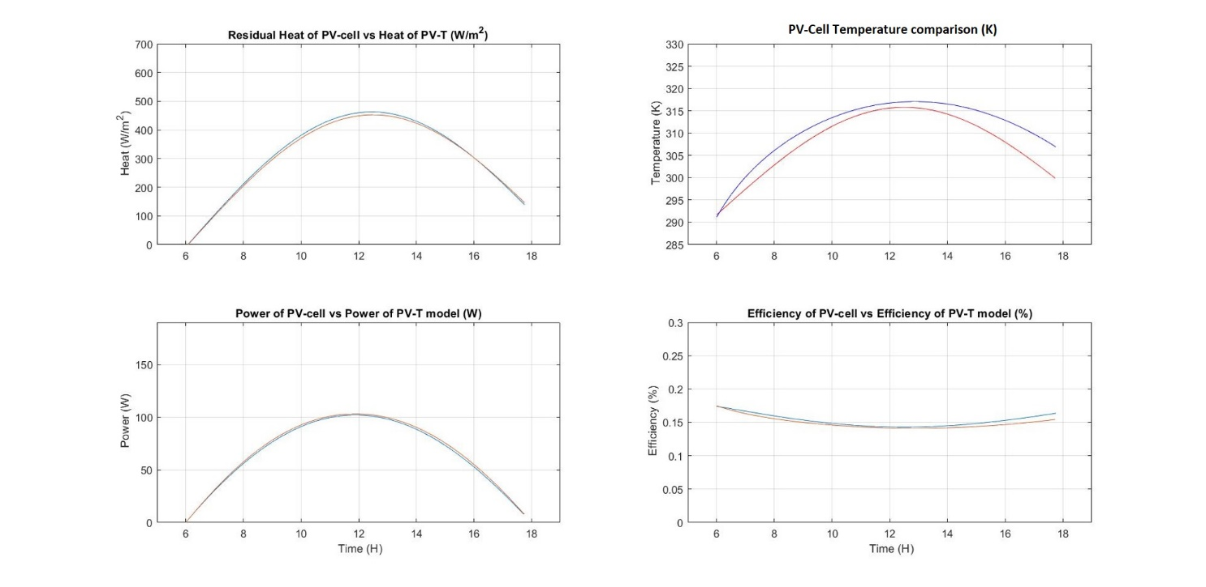



**Source**: Own

Figure 7 shows the results obtained in the photovoltaic cell integrated in the hybrid system, here you can see the characteristic curves of the photovoltaic cell; $Voltage vs. Current (V - I)$, $Voltage vs. Power (V - P)$, and $Efficiency vs. Voltage (η - V)$.

For the case of the second simulation where the temperature at which the fluid enters the system is modified, the results are presented through Figure 8-10. Where figure 8 shows the influence that the modification of the control variable has, mainly on the temperature reached by the photovoltaic cell.

The results of the third simulation are presented through Figure 11-13, where the modification that the simulation presents depends on the change in the inlet flow in the system. Where figure 11 shows the influence that the modification of the control variable has, mainly on the temperature reached by the photovoltaic cell.

**Figure 7**. Results of the 1st simulations PV-cell model.

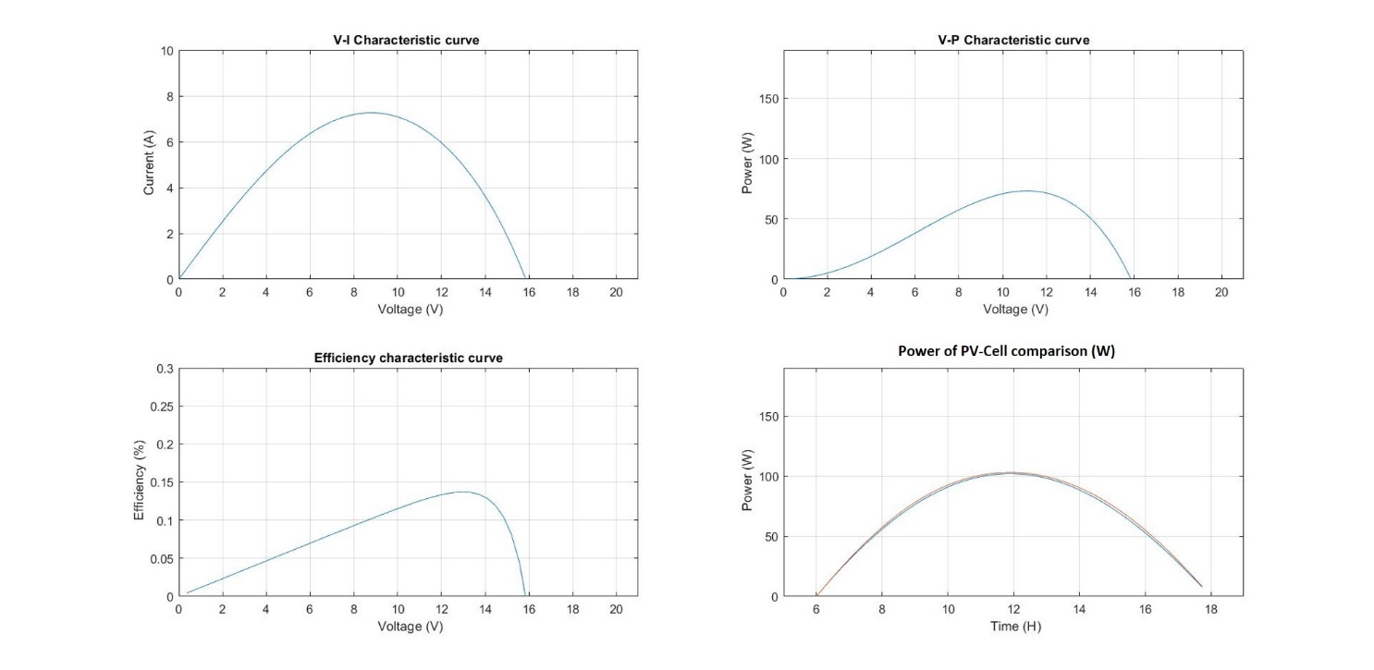



**Source**: Own

**Figure 8**. Results of the 2nd simulations of PV-cell and PV-T.

**Source**: Own

**Figure 9**. Comparative results of the 2nd simulations of PV-cell and PV-T.

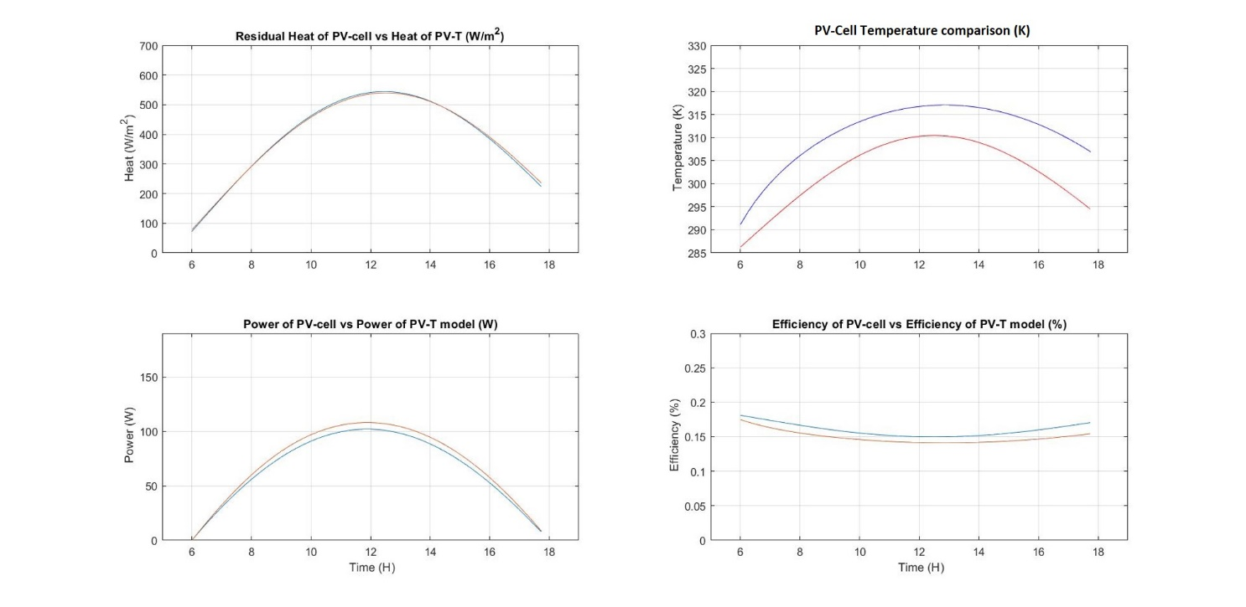



**Source**: Own

**Figure 10**. Results of the 2nd simulations of PV-cell model.

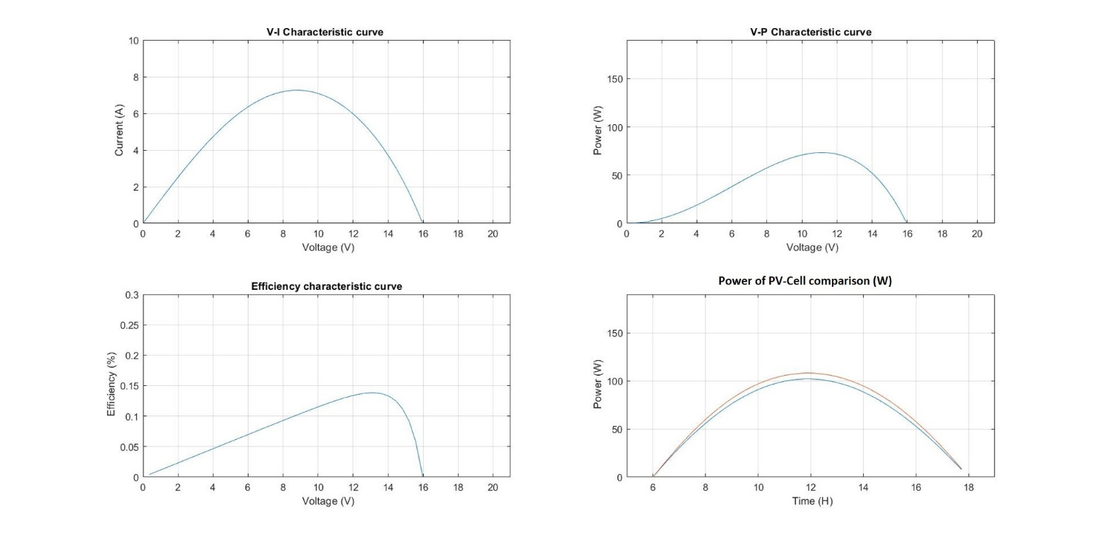

**Source**: Own

**Figure 11**. Results of the 3rd simulations of PV-cell and PV-T.

**Source**: Own

**Figure 12**. Comparative results of the 3rd simulations of PV-cell and PV-T.

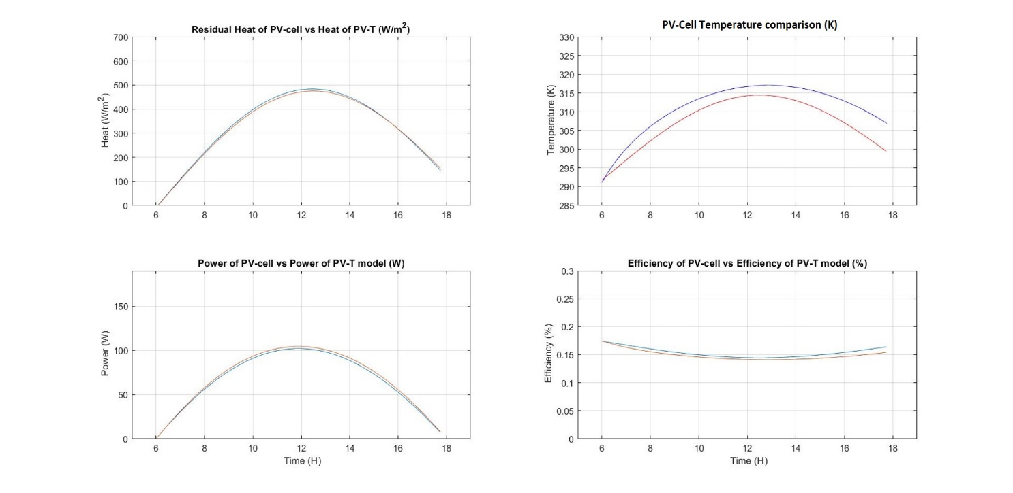

**Source**: Own

**Figure 13**. Results of the 3rd simulations of PV-cell model.

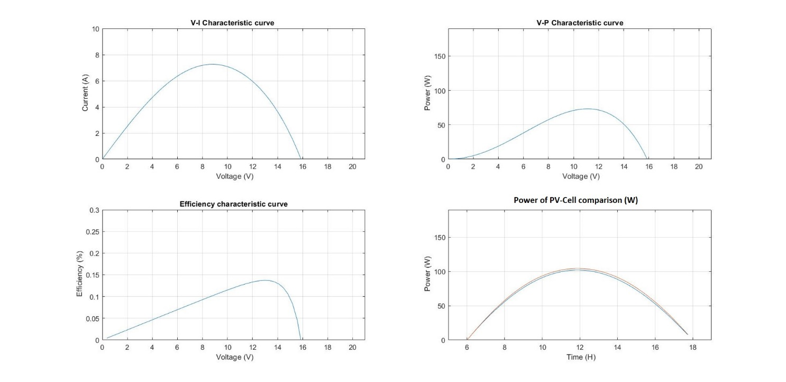

**Source**: Own

Finally, the results of the fourth simulation are presented through Figure 14-16, where the change presented by the simulation depends on the modification in the flow rate and temperature of the fluid entering the system. Where in figure 15 the influence of the modification of the control variables is observed, mainly in the temperature reached by the photovoltaic cell.

**Figure 14**. Results of the 4th simulations of PV-cell and PV-T.

**Source**: Own

**Figure 15**. Comparative results of the 4th simulations of PV-cell and PV-T.

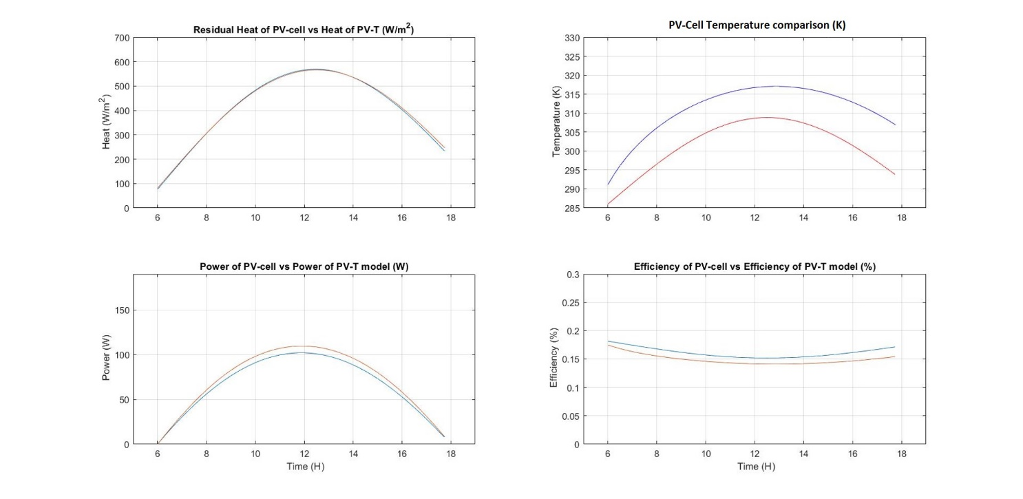

**Source**: Own

**Figure 16**. Results of the 4th simulations of PV-cell model.

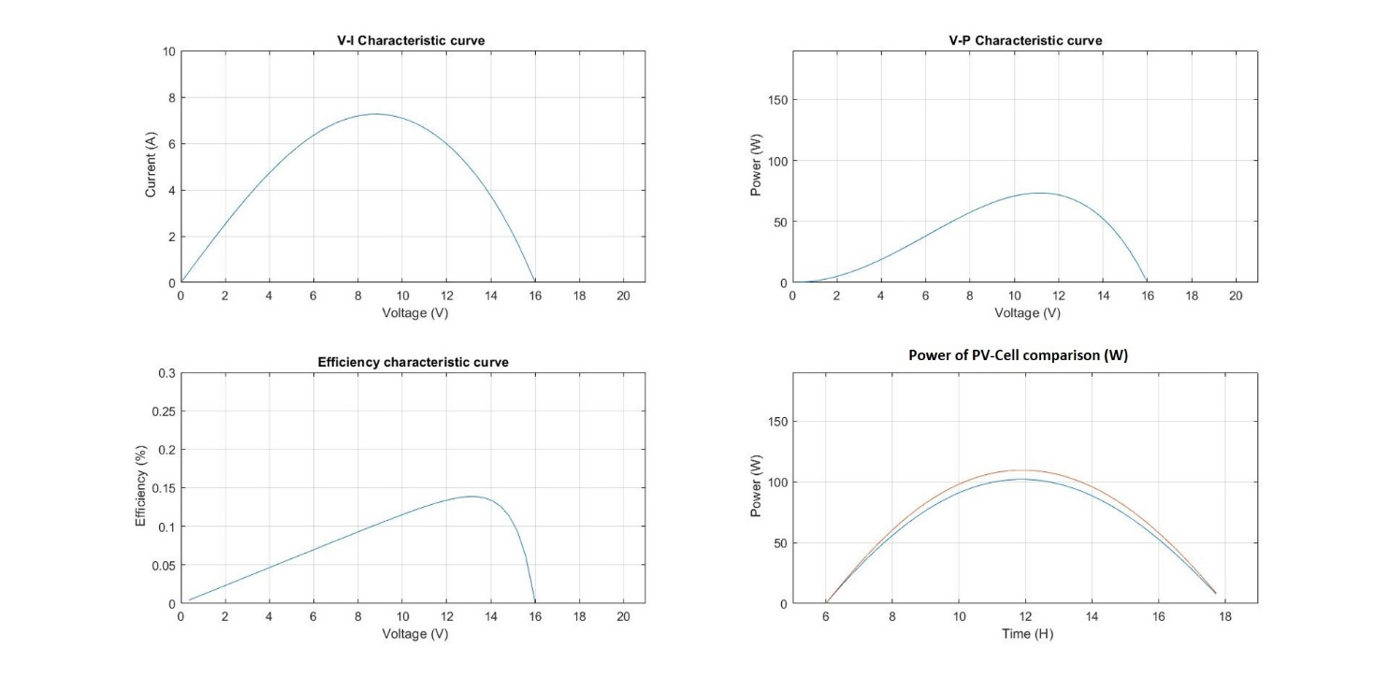

**Source**: Own

**Conclusions**

Mathematical modeling of hybrid energy systems today allows an exhaustive analysis of the behavior and capacity of hybrid systems for the transformation and generation of energy using renewable energies as a primary source. Likewise, these types of models allow estimating and modeling energy generation at a future time, considering the technical and economic feasibility of these systems.

This type of modeling of hybrid energy systems can become quite a useful tool for the designer of energy systems, potentially for large-scale power generation. Due to its adaptability as it allows adjusting algorithm parameters to quantify the amount of energy produced in the life cycle of the system, as well as adjusting the control variables to optimize the design of these systems on a large scale.

In conclusion, the model presented in this work allows analyzing and quantifying the behavior of a hybrid photovoltaic-thermal system and modeling various scenarios that allow us to optimize the design of this type of system to increase its overall efficiency by adjusting its control variables. Furthermore, it is possible to estimate various operating conditions using different solar radiation models that allow analyzing the behavior of hybrid generation systems under quasi-stable operating conditions.

In addition, as future work, we are working with the design of simulation models and evaluation of the performance of photovoltaic systems and photovoltaic hybrid systems through the use of techniques based on the internet of things and applicability to industry 4.0, in the solar plant. from the Institute of Ciudad Juarez.

**Future Research Line**

As mentioned, and according to the results, the replication of this type of project in various simulation environments and pilot plants for data collection in various regions will allow the model's capabilities to be expanded. Therefore, future work is focused on the design and development of a power generation plant from solar and hydrogen. The research objective is to work with the modeling of dynamic and chaotic systems.

**Acknowledgments (All sources of funding of the study must be disclosed.)**

I am grateful to CONACYT and the Tecnológico Nacional de México Campus Ciudad Juárez for the financial support provided during the implementation of this project, which led to the development of this article.

**References**

Amelia A.R., Irwan Y.M., Leow W.Z., Irwanto M., Safwati I., Zhafarina M. (2016), Investigation of the Effect Temperature on Photovoltaic (PV) Panel Output Performance. International Journal on Advanced Science Engineering and Information Technology., 6 (5), ISSN: 2088-5334

Apatekar, S., & Mallareddy, Ch. (2015), Mathematical Modeling of Photovoltaic Cell. International Journal of Science and Research (IJSR)., 4(4). 2950 - 2953. https://www.ijsr.net/search_index_results_paperid.php?id=SUB153861

Armstrong, S., & Hurley, W. G. (2010), A thermal model for photovoltaic panels under varying atmospheric conditions. Applied Thermal Engineering., (30), 1488-1495. https://doi.org/10.1016/j.applthermaleng.2010.03.012

Armstrong, P. (1978), Extension of the Hottel-Whillier equation to milti-stage collector systems. ASES Conference Denver 1978 Only PV (No ESS) PV & 12hr ESS PV & 6hr ESS., 2-5.

Belhadj, C., Kassas, M., & Essamuddin, S. (2015), LabVIEW Based PV Panel Online Characteristics and Parameters Estimation. Procedia Computer Science, (52), 876 – 882. https://doi.org/10.1016/j.procs.2015.05.145

Chow, T. T., Tiwari, G. N., & Menezo, C. (2012), Hybrid Solar: A Review on photovoltaic and thermal power integration. International Journal of Photoenergy., (V-2012), 1-17. https://doi.org/10.1155/2012/307287

Desisaa D. G., Shekatab G. D. (2020), Performance Analysis of Flat-Plate and V-groove Solar Air Heater Through CFD Simulation. Int. Journal of Renewable Energy Development., 9(3), 369-381.

IRENA, Global energy transformation: A roadmap to 2050 (2019 edition). International Renewable Energy Agency Abu Dhabi, 2019, 27-30. 1. Available from: https://www.irena.org/publications/2019/Apr/Global-energy-transformation-A-roadmap-to-2050-2019Edition

IRENA, Renewable energy prospects: Mexico Remap 2030.International Renewable Energy Agency Abu Dhabi. 2015, 5-7. Available from: https://www.irena.org/publications/2015/May/Renewable-Energy-Prospects-Mexico

Jangwoo, P., Hong-geun, K., Yongyun, C., & Changsun, S. (2014), Simple modeling and simulation of photovoltaic panels using MatLab/Simulink. Advanced Science and Technology Letters 2014, (73), 147-155. DOI: http://dx.doi.org/10.14257/astl.214.73.22

Jin H. J., Kadi I., Barth T., and Leszczynski E. (2017), Implementation of a large-scale solar photovoltaic system at a higher education institution in Illinois, USA, AIMS Energy, 5(1), 54-62., DOI: https://doi.org/10.3934/energy.2017.1.54

Kasaeiana A., Khanjaria Y., Golzaria S., Mahian O., and Wongwises S. (2017), Effects of forced convection on the performance of a photovoltaic thermal system: An experimental study, Experimental Thermal and Fluid Science. (85), 13-21, https://doi.org/10.1016/j.expthermflusci.2017.02.012

Kazemiana A., Salarib A., Hakkaki-Fard A. and Maa T. (2019), Numerical investigation and parametric analysis of a photovoltaic thermal system integrated with phase change material. Applied Energy. (238), 734-746, https://doi.org/10.1016/j.apenergy.2019.01.103

Khanjari Y., Pourfayaz F., and Kasaeian A.B. (2016), Numerical investigation on using of nanofluid in a water-cooled photovoltaic thermal system. Energy Conversion and Management. (122), 263-278. https://doi.org/10.1016/j.enconman.2016.05.083

Libra M., Poulek V., Kouřím P. (2017), Temperature changes of I-V characteristics of photovoltaic cells as a consequence of the Fermi energy level shift, Res. Agr. Eng., 63(1), 10–15, DOI: https://doi.org/10.17221/38/2015-RAE

Manjunath, M. S., Karanth, K. V., & Sharma, N. Y. (2018). Numerical investigation on heat transfer enhancement of solar air heater using sinusoidal corrugations on absorber plate. International Journal of Mechanical Sciences, (138–139), 219–228. https://doi.org/10.1016/j.ijmecsci.2018.01.037

Patel G. A. (2016), Application of PV Solar System in Statcom to Regulate the Active & Reactive Power in the Distribution Network, International Journal of Science and Research (IJSR), 5(6), 1275 – 1278. https://www.ijsr.net/search_index_results_paperid.php?id=NOV164464

Paz, G. J. C. (2005), Colectores solares planos: tratamiento teórico. Universidad Autónoma de Ciudad Juárez. Instituto de Ingeniería y Tecnología Chihuahua. Energía Solar, (1), 6-8, UACJ ISBN: 968-7845-78-3.

Preet S., Bhushan B., Mahajan T. (2017), Experimental investigation of water based photovoltaic/thermal (PV/T) system with and without phase change material (PCM). Solar Energy. (155), 1104-1120, https://doi.org/10.1016/j.solener.2017.07.040

Ramos, G. L. (2012), La generación de energía eléctrica en México. *Tecnología y Ciencias del Agua México.* (3), 197-211. ISSN: 0187-8336.

Sadeghzadeh, M., Ahmadi, M. H., Kahani, M., Sakhaeinia, H., Chaji, H., & Chen, L. (2019). Smart modeling by using artificial intelligent techniques on thermal performance of flat-plate solar collector using nanofluid. Energy Science and Engineering, 7(5), 1649–1658. DOI: https://doi.org/10.1002/ese3.381

SENER, PRODESEN: Programa de desarrollo del sistema eléctrico nacional 2018-2032.Secretaria de Energía 282 México. 2018, 12-23. Available from: https://www.gob.mx/cms/uploads/attachment/file/331770/PRODESEN-2018-2032-definitiva.pdf

Singh, A. P., & Singh, O. P. (2018). Performance enhancement of a curved solar air heater using CFD. Solar Energy, (174), 556–569. https://doi.org/10.1016/j.solener.2018.09.053

SOLARTRONIC, Irradiaciones global, directa y difusa en superficies horizontales e inclinadas, así como irradiación directa normal, para la república mexicana. Solartronic S.A. De C.V. 2003. Available from: http://www.solartronic.com/download/radiacion.pdf

Stropnik R., Stritih U. (2016), Increasing the efficiency of PV panel with the use of PCM, Renewable Energy, (97), 671-679. https://doi.org/10.1016/j.renene.2016.06.011

Sun V., Asanakham A., Deethayat T., Kiatsiriroat T. (2020), A new method for evaluating nominal operating cell temperature (NOCT) of unglazed photovoltaic thermal module, *Energy Reports*, (6) 1029–1042, DOI: https://doi.org/10.1016/j.egyr.2020.04.026

Syafiqah Z., Irwan YM., Amin N., Irwanto M., Leow WZ. and Amelia AR. (2017), Thermal and Electrical Study for PV Panel with Cooling System. *Indonesian Journal of Electrical Engineering and Computer Science*, (2), 492-499 DOI: https://doi.org/10.11591/ijeecs.v7.i2.pp492-499

Wu Y., Wu S., and Xiao L. (2017), Numerical study on convection heat transfer from inclined PV panel under windy environment, *Solar Energy*, (149), 1-12 https://doi.org/10.1016/j.solener.2017.03.084

Yeshalem M. T. and Khan B. (2017), Design of an off-grid hybrid PV/wind power system for remote mobile base station: A case study, *AIMS Energy*, 5(1), 96-112, DOI: https://doi.org/10.3934/energy.2017.1.96

|  |  |
| --- | --- |
| Rol de Contribución | Autor (es) |
| Conceptualización | Jeovany Rafael Rodriguez Mejia, Arturo Woocay Prieto (igual) |
| Metodología | Jeovany Rafael Rodriguez Mejia, Alfonso López Martínez (apoyo) |
| Software | Jeovany Rafael Rodriguez Mejia, Ulises Martínez Contreras (apoyo) |
| Validación | Jeovany Rafael Rodriguez Mejia, Arturo Woocay Prieto (igual), Alfonso López Martínez (apoyo) |
| Análisis Formal | Jeovany Rafael Rodriguez Mejia, Ulises Martínez Contreras (apoyo) |
| Investigación | Jeovany Rafael Rodriguez Mejia, Alfonso López Martínez (apoyo) |
| Recursos | Arturo Woocay Prieto, Alfonso López Martínez, Adán Valles Chávez, (Apoyo) |
| Curación de datos | Adán Valles Chávez, Alfonso López Martínez (apoyo) |
| Escritura - Preparación del borrador original | Jeovany Rafael Rodriguez Mejia |
| Escritura - Revisión y edición | Jeovany Rafael Rodriguez Mejia |
| Visualización | Arturo Woocay Prieto, Jeovany Rafael Rodriguez Mejia, Adán Valles Chávez (apoyo) |
| Supervisión | Jeovany Rafael Rodriguez Mejia, Adán Valles Chávez (apoyo) |
| Administración de Proyectos | Jeovany Rafael Rodriguez Mejia |
| Adquisición de fondos | Ulises Martínez Contreras |

**Appendix A.**

$$Appendix A.1. Photovoltaic Cell Model$$

$$4 parameters model$$

$$I = IL - ID= IL - Io [exp((V + I*Rs)/(a))-1]$$

$$IL= (A) ———– I= (A)$$

$$Io= (A) ———– V= (V)$$

$$Rs= (Ohms) ———– a = (A/K)$$

$$— 1st Parameter —$$

$$IL= (\frac{G.}{G_{ref}}).*\left(IL_{ref} + usc.*\left(T_{c}-T_{cref}\right)\right);$$

$$— 2nd Parameter —$$

$$a_{ref}= ((2.* V_{mp})- V_{oc})./(((I_{sc})/(I_{sc}-I_{mp}))+log(1-((I_{mp})/(I_{sc}))));$$

$$I_{o}= (IL_{ref}).* (exp(-V_{ocref}./a_{ref})).* ((T_{cref}./T_{c})^3 ). * (exp((Ns. * eg./q. * a_{ref}). * ((1./T_{cref}) - (1./T_{c}))));$$

$$- - - 3rdParameter - - -$$

$$a = ((T_{cref})./(T_{c})). * a_{ref} ;$$

$$- - - 4thParametro - - -$$

$$R_{s} = (((2. * V_{mp}) - V_{oc})./(((I_{sc})/(I_{sc} - I_{mp})) + log(1 - ((I_{mp})/(I_{sc}))))). * (((log(1 - ((I_{mp})./(I_{sc})))) + (V_{oc}) - (V_{mp}))./(I_{mp}));$$

$$— Current —$$

$$I = I_{L} - I_{o}.*(exp((V + I*R_{s})/(a))-1);$$

$$I= 5;$$

$$Ip=[];$$

$$for i=1:10$$

$$I_{c} = I_{L} - ((I_{o}.*(exp((V + I.*R_{s})./(a))-1)));$$

$$e_{pv} = abs(I_{c}-I);$$

$$I_{p}=[e_{pv} I_{p}];$$

$$I = I_{c};$$

$$end$$

$$I1= I;$$

$$P= I_{1}.*V;$$

$$N_{cel}=(P)./(G.*A_{c});$$

$$Appendix A.2. Flat Plate Collector Model$$

$$— Fluid properties —$$

$$cp_{f}= 4210.1 - 1.313162*T_{f} + 0.01352294*(T_{f}^{2} );$$

$$ro_{f} = 1002.1 - 0.1728604 * T_{f} - 0.002600578 * (T_{f}^{2} );$$

$$k_{f} = 0.57098 + 0.001746321 * T_{f} - (6.42969e^{-6}) * (T_{f}^{2} );$$

$$mu_{f} = (1.736107e^{-3} ) - ((4.87698e^{-5}) * T_{f}) + ((7.409839e^{-7}) * (T_{f}^{2} )) - ((6.075131e^{-9}) * (T_{f}^{3} )) + ((2.489452e^{-11}) * (T_{f}^{4} )) - ((3.9750877e^{-14}) * (T_{f}^{5} ));$$

$$- - - h_{fi} - - -$$

$$Re = (4 * fmxT)/(pi * di * mu_{f});$$

$$Pr = (mu_{f} * cp_{f})/(k_{f});$$

$$if Re < 2300$$

$$- - - constant heat flow - - -$$

$$if fq == 1;$$

$$Nua = 4.4;$$

$$if Pr≤ 0.7$$

$$a1 = 0.00398; b1 = 0.0114; m1 = 1.66; n1 = 1.12;$$

$$elseif Pr <= 10$$

$$a1 = 0.00236; b1 = 0.00857; m1 = 1.66; n1 = 1.13;$$

$$else$$

$$a1 = 0.00172; b1 = 0.00281; m1 = 1.66; n1 = 1.29;$$

$$end$$

$$— Wall temperature —$$

$$else$$

$$Nua= 3.7;$$

$$if Pr<= 0.7$$

$$a1= 0.0791; b1= 0.0331; m1= 1.15; n1= 0.82;$$

$$elseif Pr<= 10$$

$$a1= 0.0534; b1= 0.0335; m1= 1.15; n1= 0.82;$$

$$else$$

$$a1= 0.0461; b1= 0.0316; m1= 1.15; n1= 0.84;$$

$$end$$

$$end$$

$$— Nusselt —$$

$$Nu= Nua + ((a1*(Re*Pr*(di/l2))m1)/(1 + (b1 * (Re * Pr * (di/l2))n1)));$$

$$else$$

$$Nu = 0.023 * (Re(4/5)) * (Pr(1/3));$$

$$end$$

$$h_{fi}= (Nu * k f /di);$$

$$U_{pf} = Ka/ea f ;$$

$$U_{pb} = ((Ka/e_{ab}) * (Pc * Ct))/(AC);$$

$$U_{p} = U_{pf} + U_{pb};$$

$$m = ((U p)/(Kp * tp))(0.5);$$

$$na = (tanh((m/2) * (W - de)))/((m/2) * (W - de));$$

$$Fp = (1/U_{p})/(W * ((1/(U_{p} * (de + ((W - de) * na)))) + (1/C_{s}) + (1/(pi * di * h_{fi}))));$$

$$FR = ((fm * Cp)/(U_{p} * AC)) * (1 - exp((-U_{p} * AC * F_{p})/(fm * Cp)));$$