https://doi.org/10.23913/ride.v16i32.2875
Artículos científicos
Gestión comunitaria de residuos sólidos urbanos: un estudio de caso en una comunidad rural de Guerrero, México

Community-based management of municipal solid waste: A case study in a rural community of Guerrero, Mexico

Gestão comunitária de resíduos sólidos urbanos: um estudo de caso em uma comunidade rural de Guerrero, México.

Javier Saldaña Almazán
Autonomous University of Guerrero, México
cvujsa@gmail.com
https://orcid.org/0000-0003-1832-9333

José Luis Rosas Acevedo
Autonomous University of Guerrero, México
jlrosas@uagro.mx
https://orcid.org/0000-0003-2744-7454

Enrique Moreno Mendoza
Autonomous University of Guerrero, México
08226185@uagro.mx
https://orcid.org/0009-0001-7137-6764

Ana Patricia Leyva Zuñiga*
Autonomous University of Guerrero, México
analeyva@uagro.mx
https://orcid.org/0000-0003-1941-1531

Mirella Saldaña Almazán*
Autonomous University of Guerrero, México
msaldana@uagro.mx
https://orcid.org/0000-0001-8995-1803

* Corresponding authors
Resumen
La gestión inadecuada de los residuos sólidos urbanos (RSU) en zonas rurales del sur de México constituye un problema ambiental y de salud pública significativo, asociado a limitaciones estructurales, insuficiente cobertura de los servicios municipales y ausencia de un marco normativo local. El objetivo de este estudio fue describir las prácticas locales de gestión de RSU, identificar capacidades institucionales y comunitarias, y proponer alternativas sostenibles mediante un enfoque participativo en la localidad de Las Ánimas, municipio de Tecoanapa, Guerrero. Se realizó una investigación exploratoria-descriptiva con enfoque de métodos mixtos. La recolección de información incluyó entrevistas semiestructuradas con autoridades municipales y comunitarias, encuestas estructuradas aplicadas a una muestra probabilística de 201 hogares mediante muestreo aleatorio simple, y un grupo focal orientado al diseño de propuestas comunitarias. Se analizaron aspectos operativos relacionados con la generación, recolección, transporte y disposición final de los residuos, así como percepciones locales y conocimiento ambiental. Los resultados indican una generación promedio de 0,5987 kg/hab/día, un servicio de recolección quincenal limitado a las calles principales y la ausencia de regulaciones locales específicas. La disposición final inadecuada en barrancos, ríos y áreas agrícolas genera impactos negativos sobre suelos y cuerpos de agua. Asimismo, se identificaron prácticas tradicionales de aprovechamiento de residuos orgánicos sin control sanitario. No obstante, la población manifestó disposición para participar en estrategias comunitarias de gestión. A partir del diagnóstico participativo se propuso un modelo basado en la creación de comités comunitarios, centros de acopio, separación en la fuente y compostaje. Los resultados resaltan la importancia de fortalecer esquemas de gobernanza participativa que integren innovación técnica, marcos normativos comunitarios y conocimiento local para avanzar hacia un modelo de gestión sostenible de residuos adaptado al contexto rural.
Palabras clave: gestión comunitaria, residuos sólidos urbanos, comunidad rural, gobernanza local, desarrollo local, conocimiento ambiental.

Abstract
Inadequate management of municipal solid waste (MSW) in rural areas of southern Mexico represents a major environmental and public health challenge, associated with structural limitations, insufficient coverage of municipal services, and the absence of local regulatory frameworks. This study aimed to describe local MSW management practices, identify institutional and community capacities, and propose sustainable alternatives through a participatory approach in the locality of Las Ánimas, municipality of Tecoanapa, Guerrero, Mexico. An exploratory-descriptive study with a mixed-methods approach was conducted. Data collection included semi-structured interviews with municipal and community authorities, structured surveys applied to a probabilistic sample of 201 households, and a focus group aimed at designing community proposals. Operational aspects of waste generation, collection, transportation, and final disposal were analyzed, along with local perceptions and environmental knowledge. The results indicate an average waste generation of 0.5987 kg per capita per day, a biweekly collection service limited to the main streets, and the absence of local regulations governing waste management. Inadequate disposal in ravines, rivers, and agricultural areas generates negative impacts on soils and water bodies. Traditional practices of organic waste reuse were also identified, although without sanitary control. The community showed a strong willingness to participate in collective strategies, which allowed the formulation of a participatory proposal based on local committees, community waste collection points, source separation, and composting. These findings highlight the importance of strengthening participatory governance schemes that integrate technical innovation, community regulations, and local environmental knowledge to develop sustainable waste management models adapted to rural contexts.
Keywords: community-based management, municipal solid waste, rural community, local governance, local development, environmental knowledge.

Resumo
A gestão inadequada de resíduos sólidos urbanos (RSU) em áreas rurais do sul do México representa um grande desafio ambiental e de saúde pública, associado a limitações estruturais, cobertura insuficiente dos serviços municipais e ausência de marcos regulatórios locais. Este estudo teve como objetivo descrever as práticas locais de gestão de RSU, identificar as capacidades institucionais e comunitárias e propor alternativas sustentáveis ​​por meio de uma abordagem participativa na localidade de Las Ánimas, município de Tecoanapa, Guerrero, México. Foi realizado um estudo exploratório-descritivo com abordagem mista. A coleta de dados incluiu entrevistas semiestruturadas com autoridades municipais e comunitárias, questionários estruturados aplicados a uma amostra probabilística de 201 domicílios e um grupo focal com o objetivo de elaborar propostas comunitárias. Foram analisados ​​aspectos operacionais da geração, coleta, transporte e destinação final dos resíduos, juntamente com as percepções locais e o conhecimento ambiental. Os resultados indicam uma geração média de resíduos de 0,5987 kg per capita por dia, um serviço de coleta quinzenal limitado às ruas principais e a ausência de regulamentação local para a gestão de resíduos. O descarte inadequado em ravinas, rios e áreas agrícolas gera impactos negativos nos solos e corpos d'água. Práticas tradicionais de reutilização de resíduos orgânicos também foram identificadas, embora sem controle sanitário. A comunidade demonstrou grande disposição para participar de estratégias coletivas, o que possibilitou a formulação de uma proposta participativa baseada em comitês locais, pontos de coleta comunitários de resíduos, separação na fonte e compostagem. Esses resultados destacam a importância de fortalecer os modelos de governança participativa que integrem inovação tecnológica, regulamentações comunitárias e conhecimento ambiental local para desenvolver modelos sustentáveis ​​de gestão de resíduos adaptados a contextos rurais.
Palavras-chave: gestão comunitária, resíduos sólidos urbanos, comunidade rural, governança local, desenvolvimento local, conhecimento ambiental.
Fecha Recepción: Noviembre 2025 Fecha Aceptación: Enero 2026

Introduction
The constant growth of the population, urbanization processes, and the expansion of economic activities have caused a notable increase in the generation of municipal solid waste (MSW) at the global level, with projections suggesting that by 2050 production could reach 3.4 billion tons per year (Kibria et al., 2023; Zhang et al., 2024). This phenomenon has become a crucial challenge for waste management systems, especially in countries in the Global South, where limitations in technology, financing, and governance hinder the implementation of comprehensive solutions (Lakhouit, 2025; Margallo et al., 2019).
In Mexico, the General Law for the Prevention and Integral Management of Waste (LGPGIR) establishes that MSW refers to waste generated in households, commercial establishments, institutions, and public spaces with residential characteristics, including those derived from street sweeping and the cleaning of public areas. According to Article 115 of the Political Constitution of the United Mexican States, municipal governments are responsible for the collection, transfer, treatment, and final disposal of these wastes. However, significant gaps remain between what regulations establish and the real capacity of municipalities to comply with these obligations.
In the state of Guerrero, daily MSW generation is estimated at approximately 6,031 tons per day, with notable inequalities in service coverage and quality between urban and rural areas. Of the 81 municipalities in the state, only six meet the technical criteria required to operate controlled disposal sites or sanitary landfills, which implies that a large portion of waste ends up in open dumps, generating greenhouse gas emissions, leachate contamination, and negative effects on public health (Brito et al., 2023; Ferronato & Torretta, 2019; Kiehbadroudinezhad et al., 2024; Koliyabandara et al., 2024).
In rural contexts such as the municipality of Tecoanapa, these structural limitations are exacerbated by the geographic dispersion of settlements, insufficient waste collection routes, and the lack of infrastructure for the final disposal of MSW (Del Carmen Niño et al., 2023; Przydatek et al., 2025). Recent studies have demonstrated that participatory governance and the inclusion of local environmental knowledge are essential to improve the efficiency of waste management systems, promote shared responsibility, optimize resources, and encourage sustainable practices such as waste separation at the source and decentralized composting (Ammann et al., 2023; Del Carmen Niño et al., 2019).
The locality of Las Ánimas, located in the municipality of Tecoanapa, represents a case that reflects the structural and socio-environmental conditions that limit the integrated management of MSW in rural areas characterized by high levels of marginalization. With an estimated generation of 0.5987 kg per inhabitant per day (Chupín-Hermenegildo et al., 2014; Zuñiga et al., 2025) and the presence of multiple open dumps, inadequate disposal practices generate negative impacts on soils, water bodies, and community health. This situation is further aggravated by the absence of local regulatory frameworks and the low frequency of waste collection services (Juárez-López et al., 2015).
In this context, it is necessary to develop comprehensive strategies that combine technical innovation, institutional strengthening, and community participation in order to advance toward an environmentally sustainable waste management model adapted to the territorial characteristics of rural communities (Brown et al., 2016; Ioppolo et al., 2016).
Therefore, the present study aims to characterize local waste management practices, identify institutional and community capacities, and propose sustainable alternatives through a participatory approach, contributing empirical evidence to the scientific discussion on community-based municipal solid waste management in rural environments.

Materials and methods
The study was carried out in Las Ánimas, an area that is part of the municipality of Tecoanapa, located in the Costa Chica region in the state of Guerrero, Mexico. This locality is located at coordinates 99°19'10.618'' west longitude and 16°58'17.388'' north latitude, at an average altitude of 657 meters above sea level (Suastegui Cruz et al., 2017).
The community has a population of 1,565 people, of which 750 are men and 815 are women, distributed in 421 households. Despite being 127 kilometers from the city of Acapulco, the locality presents a high degree of marginalization.
This research corresponds to a single case study conducted in the rural locality of Las Ánimas (Tecoanapa, Guerrero, Mexico), using an exploratory-descriptive design with a mixed-methods approach and a participatory perspective, in order to characterize local MSW management practices and co-design sustainable alternatives together with community actors.
This study uses a mixed approach that combines qualitative and quantitative methods to carry out a comprehensive analysis of municipal solid waste management in the community. An exploratory and descriptive perspective was also adopted to identify local practices in waste management, evaluate the capabilities of both institutions and the community, and propose sustainable options from a participatory approach.
Information collection was carried out in three phases:

Municipal diagnosis
An interview was conducted with the Director of Public Services of the Municipal Government of Tecoanapa in order to understand the regulations, operations, and logistics related to the management of municipal solid waste in the locality.
Waste management strategies, available equipment, collection routes, service frequency, and attention to rural areas were addressed, including the locality of Las Ánimas. This information was useful to understand the structural conditions and operational limitations of the municipal waste management system.

Community diagnosis with local authorities
To understand the situation in the area, semi-structured interviews were carried out with the Comisariado de Bienes Comunales, the Comisariado Municipal, and a community representative.
These conversations helped to recognize the ways in which waste is managed, the locations used for waste disposal, community practices, levels of social organization, and the implications of these factors for environmental issues.
The qualitative data were coded and analyzed using ATLAS.ti (Scientific Software Development GmbH, Berlin, Germany). Figure 6 was generated based on the coded categories and their relationships identified during the analysis, in order to represent the socio-environmental perception of local authorities.

Community diagnosis of Las Ánimas
A socio-environmental study was carried out with a representative sample of the community. A simple random sample was applied, covering a total of 201 households.
This study incorporated questions about the amount of waste generated daily, waste disposal methods, collection frequency, and the level of knowledge about the environmental impacts they cause. Questions were also included about the willingness to participate in community initiatives aimed at addressing environmental problems.

Community proposal for urban solid waste in the community of Las Ánimas
This proposal is based on the information collected during the previous stages. For this purpose, a working group was formed consisting of several members of the community, including residents, young people, women, farmers, and other community actors. The objective was to reflect collectively on the results of the diagnosis and develop a community proposal for the integrated management of municipal solid waste.
The working group helped recover environmental knowledge, identify sustainable practices, and establish strategies that could be implemented by community organizations in cooperation with local authorities.
As a result of this participatory experience, the proposal was structured using a Logical Framework Matrix following the approach proposed by Suastegui Cruz & Gallardo López (2024).

Results
The Tecoanapa Municipal Government is the entity responsible for the management and integrated handling of municipal solid waste (MSW). However, it lacks the necessary infrastructure to ensure collection in all localities of the municipality. This limitation is compounded by the absence of a controlled final disposal site, which represents non-compliance with NOM-083-SEMARNAT-2003.
This deficiency has led to inadequate practices in both the management and final disposal of waste, generating significant environmental problems. A lack of institutional knowledge regarding proper management techniques was identified, associated with the absence of continuity and communication between successive municipal administrations. There is no mechanism to ensure the transfer of information or technical documentation between local governments, which limits traceability and transparency in actions related to MSW management.
The interview conducted allowed the identification of general aspects of current waste management practices in the municipality (Figure 1, Table 1).

Figure 1. Flowchart of the urban sanitation system in the municipality of Tecoanapa, Guerrero.
Collection
Transport
Final disposal
Generation
Sweeping

Source: Authors’ elaboration

Table 1. Current processes and conditions of municipal solid waste management in Tecoanapa, Guerrero
Management stage | Description
Generation | Waste generated in households, businesses, and public areas.
Sweeping | It is carried out only in the municipal seat through manual street sweeping. Twenty workers participate, receiving a daily wage of $150. Additional activities include cleaning offices and public spaces. The tools used include brooms and wheelbarrows.
Collection | Mixed waste collection without separation. In the municipal seat, the service is curbside. In ten rural localities (22% of the total), collection is carried out only along the main street once a week.
Transport | Three dump trucks (non-specialized), each with a capacity of 7 m³. Total waste collection is estimated at approximately 8 tons per day.
Final disposal | Type D site (<50 tons/day according to NOM-083-SEMARNAT-2003). The site does not comply with regulatory technical criteria. Waste is transported to the site without treatment and disposal is partially controlled through burning.
Informal recycling | Three waste pickers collect PET, which is sold at $1.50/kg to a recycling intermediary who collects the material directly at the site.
Site ownership | The disposal site occupies an area of six hectares. The land is privately owned, with a monthly rent of $15,000. An additional payment of $8,000 is made to another individual to allow access for waste collection trucks.
Source: Authors’ elaboration
The municipal solid waste management system presents significant structural and socio-environmental deficiencies throughout all operational stages. The cycle begins with the transport of waste using municipal vehicles to the disposal site, where the absence of adequate infrastructure and waste management practices can be observed under open-air conditions (Figure 2 and 3).

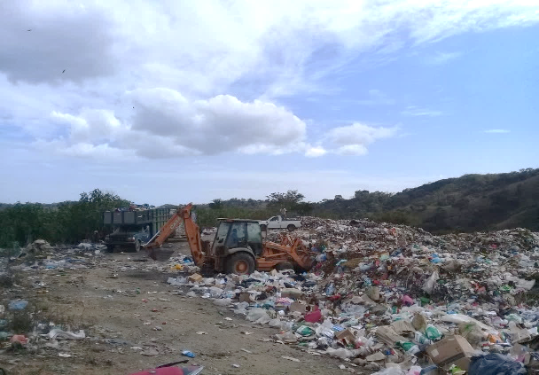
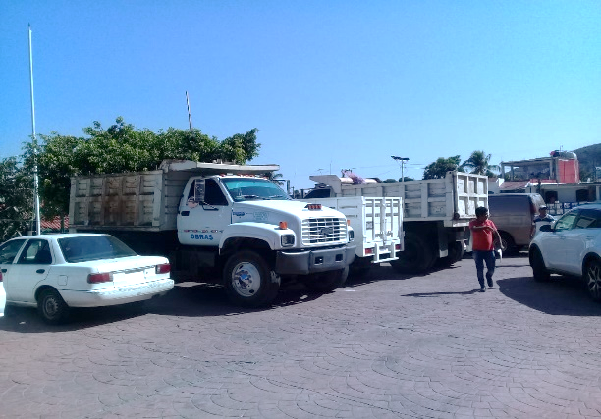
Figure 2. (a) Vehicles used for the transportation of municipal solid waste and (b) Final disposal site.
- (b)
Source: Authors’ photograph (2025)

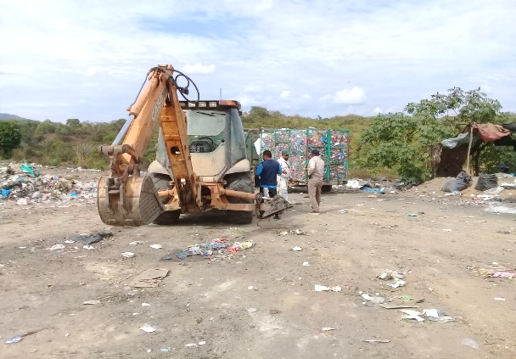
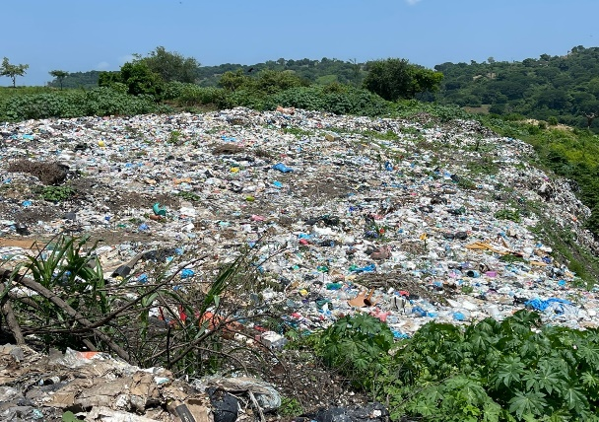
Figure 3. (a) Dispersion of waste at the final disposal site and (b) PET buyers.

- (b)

Source: Authors’ photograph (2025).
The uncontrolled accumulation and dispersion of waste materials over large areas generates negative impacts on surrounding environments, affecting soil quality, water resources, and public health. In this context, institutional management remains insufficient to address the magnitude of the problem. Informal social actors, such as waste pickers and PET recyclers, play an important role in recovering recyclable materials. These activities constitute a subsistence circular economy that contributes to reducing waste volumes but operates without formal recognition or institutional support from government authorities, highlighting the need to strengthen environmental governance through participatory and sustainable strategies.
In the context of the community of Las Ánimas, the analysis of social perception revealed a complex situation that reflects the influence of multiple actors and factors involved in MSW management (Figure 4).

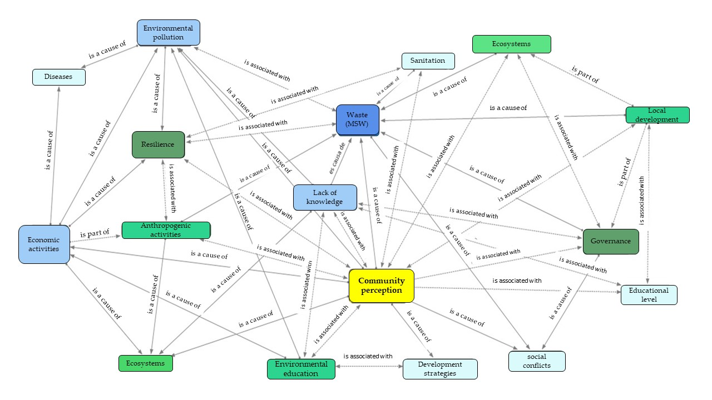
Figure 4. Socio-environmental perception of local authorities in Las Ánimas
Source: Authors’ elaboration based on interviews.
In this context, community perceptions constitute a key element for understanding changes in environmental awareness at the local level. Residents demonstrate considerable knowledge about environmental processes, reflected in symbolic interpretations of the relationship between society and nature. However, this knowledge does not always translate into sustainable environmental practices.
Although the importance of environmental education is widely recognized, environmental protection is often perceived as dependent on effective local governance capable of integrating diverse perspectives and coordinating the participation of multiple social actors.
In Las Ánimas, the community maintains a close relationship with its surrounding natural environment, using local resources in everyday activities. However, environmental contamination has affected water sources, rivers, streams, and agricultural lands, mainly due to surface runoff and inadequate waste disposal practices.
Faced with the limited availability of public waste management services, residents implement local strategies to manage waste while expecting institutional support from municipal authorities. However, the growing pressure on natural resources has exceeded the ecological capacity of the surrounding ecosystems.
One of the most significant challenges identified is the need to strengthen community organization to promote active participation in environmental decision-making processes. However, community dynamics (Figure 5) continue to limit collective environmental management.

Figure 5. Open dumps in the community of Las Ánimas.
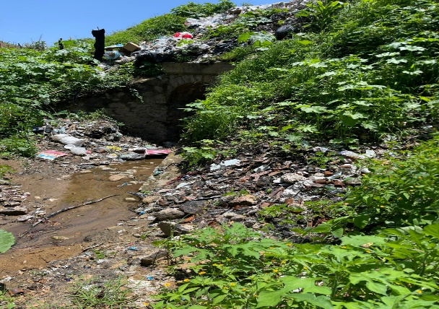

Source: Authors’ photograph (2025).
The absence of adequate sanitation services has led to illegal dumping of municipal solid waste in vacant lots and agricultural areas, resulting in the formation of multiple open dumps and generating social conflicts within the community.
From the survey conducted with 201 households in the community of Las Ánimas, data were obtained that allow characterization of the current situation of MSW management in the locality. The results indicate that although a waste collection truck provides service in the community, the low frequency of collection (every 15 days) and the limitation of the service to the main streets lead to waste accumulation and inadequate disposal in ravines, rivers, and streams. A portion of organic waste is reused as feed for domestic animals, reflecting traditional reuse practices without formal sanitary regulation.
Likewise, the absence of community or municipal regulations governing waste management and the limited knowledge of environmental legislation reflect a regulatory gap that restricts effective waste management. Nevertheless, the population expressed a clear willingness to participate in the development of community proposals aimed at improving waste management conditions.
This information, summarized in Table 2, constitutes a diagnostic basis for the development of strategies for sustainable management and local environmental governance in the community.

Table 2. Solid waste management in the community of Las Ánimas
Aspect | Description
Collection service | There is a collection service using a garbage truck.
Collection frequency | The garbage truck passes every 15 days.
Main collection routes | Collection is carried out only along the main streets of the community.
Waste destination in the absence of service | During periods without collection, solid waste is deposited in ravines, rivers, and streams. Part of it is used as feed for domestic animals (Figure 6).
Difficulties in waste disposal | The community faces difficulties in properly disposing of solid waste, mainly due to the low frequency of the service and the lack of infrastructure (Figure 6).
Knowledge about regulations | There are no community or municipal regulations governing solid waste management. There is also no widespread knowledge about environmental laws.
Community participation | There is a willingness among the population to participate in the development of community proposals for the management of urban solid waste.
Source: Own elaboration

In the case of the logical framework matrix (Table 3) it has the purpose of structuring the results and the community proposals arising from social groups. This instrument will be implemented and adjusted once the final proposal is evaluated with all interested parties, to guarantee its technical, social and environmental viability.

Table 3. Community proposal for the management of urban solid waste in Las Ánimas, municipality of Tecoanapa, Guerrero
Narrative summary | Verifiable indicators | Means of verification | Basic assumptions
Goal | Community environmental assessments show a 50% reduction in visible pollution at critical points. | Municipal political will and active community participation. | Reduce environmental pollution caused by inadequate management of urban solid waste (USW) in Las Ánimas.
Purpose | Functional system of separation and disposal implemented in at least 80% of households. | Availability of material and human resources for its implementation. | Implement a sustainable community system for the integrated management of USW with a participatory approach and local governance.
Components  1. Creation of a community committee for USW management.  2. Implementation of separation, recycling, and composting programs.  3. Development of a community regulation on USW management. | 1. Committee formed and operational within the first 6 months.  2. Installation of 2 collection centers and adoption of composting in at least 30 households.  3. Regulation approved in a community assembly. | 1. Committee meeting minutes.  2. Registry of participating households.  3. Copy of the regulation signed by local authorities. | Continuous interest of social actors; technical support available.
Activities  1.1 Conduct environmental education workshops.  1.2 Form the community committee.  2.1 Prepare spaces for collection centers.  2.2 Provide training in composting techniques.  3.1 Draft and approve the community regulation. | 1.1 At least 3 workshops conducted with 60% population attendance.  1.2 Committee established in a general assembly.  2.1 Spaces prepared within the first year.  2.2 30 households actively composting.  3.1 Regulation approved within the first year. | 1.1 Attendance lists and educational materials.  1.2 Constitution minutes.  2.1 Photographs and technical reports.  2.2 Composting logs.  3.1 Official copy of the approved regulation. | Good communication among stakeholders; community willingness; municipal support.

Source: Own elaboration

Discussion
Tecoanapa is one of the municipalities in the state of Guerrero that faces serious environmental contamination problems derived from human activities, which pose a direct risk to natural resources that are essential for both economic activities and household subsistence (Suastegui Cruz & Rosas Acevedo, 2024). One of the main sources of pollution in rural localities is the generation and inadequate management of municipal solid waste (MSW). At the municipal level, waste generation has been estimated at an average of 0.3793 kg per capita per day, a situation associated with limitations in daily public collection services and the absence of controlled waste management systems (Juárez-López et al., 2015). In this context, MSW management in rural Guerrero should be understood not only as an operational challenge but also as a structural environmental problem related to territorial inequalities in access to basic services.
In the locality of Las Ánimas, located in the municipality of Tecoanapa, residents generate an average of 0.5987667 kg of solid waste per capita per day (Zuñiga et al., 2025), exceeding the municipal average and increasing pressure on local environmental conditions. This waste is disposed of in 18 open dumps (Zuñiga et al., 2025), which are distributed across canals and agricultural areas. This situation becomes particularly critical considering that approximately 70% of the population is engaged in agricultural activities as one of their main sources of livelihood (Moreno Mendoza et al., 2024; Suastegui Cruz et al., 2017; Suastegui Cruz & Gallardo López, 2024; Suastegui Cruz & Rosas Acevedo, 2024). Therefore, the impacts of inadequate MSW management in Las Ánimas go beyond sanitation concerns and represent an environmental and productive risk that affects agricultural landscapes, rural livelihoods, and community well-being.
Specialized literature highlights that effective governance in MSW management is essential to improve institutional performance, particularly in countries of the Global South, where significant gaps persist in service coverage, financing mechanisms, and regulatory enforcement. Governance assessment tools such as the Municipal Solid Waste Governance Index (IGRSM) have been proposed to evaluate transparency, government effectiveness, and stakeholder participation in waste management systems (Iqbal et al., 2025; Pariso & Marino, 2025; Sasahara et al., 2024).
From this perspective, the limitations documented in Las Ánimas cannot be attributed exclusively to household waste practices but rather to broader governance conditions that restrict the capacity of municipal authorities to provide consistent collection services and implement controlled waste management strategies. Consequently, improving MSW management requires co-production models in which municipal authorities and organized citizens share responsibilities through stable financing mechanisms and clear regulatory frameworks (Azme et al., 2023; Rodzi et al., 2023).
Evidence from emerging urban contexts such as Rio de Janeiro demonstrates that organized community participation supported by strong local social capital can promote waste separation at the source, decentralized composting practices, and civic monitoring processes. These initiatives have been shown to reduce waste dispersion in productive areas and improve the operational efficiency of collection systems (Iacoboaea et al., 2025; Liu et al., 2022).
Similarly, research conducted in rural municipalities of southern Mexico indicates that community participation and shared responsibility are fundamental elements for reducing waste generation and promoting reuse and recycling practices, particularly when collection services exist and can be optimized through coordinated local agreements (Del Carmen Niño et al., 2019; Del Carmen-Niño et al., 2023).
At the same time, studies focused on environmental education and local knowledge emphasize that programs incorporating traditional environmental knowledge and community practices, such as the use of organic matter in agricultural systems, community cleaning arrangements, and neighborhood committees, tend to achieve greater social legitimacy and long-term sustainability in rural contexts (Anokye & Mohammed, 2024; He et al., 2022; Madonsela et al., 2024).
These findings support the idea that MSW management strategies in rural territories should be designed according to territorial realities and local governance structures, rather than replicating management models originally designed for urban environments.
In the specific case of Las Ánimas, the evidence suggests the feasibility of implementing a mixed governance model that combines participatory governance mechanisms (such as community committees and collective agreements) with technical innovations including route optimization, micro-collection centers, and culturally adapted environmental education strategies.
Such an approach could contribute to reducing waste dispersion in agricultural areas, gradually closing high-risk dumping sites, and strengthening social co-responsibility through coordinated collaboration between community actors and municipal authorities (Leyva-Zuñiga et al., 2021; Zuñiga et al., 2025).
Furthermore, improving MSW management in Las Ánimas represents an opportunity for local development, since protecting agricultural landscapes, reducing environmental risks, and improving sanitation conditions can strengthen the economic base of rural households.
Therefore, local waste governance becomes a strategic component of rural territorial development, not only in terms of environmental protection but also in relation to maintaining productive activities and strengthening community resilience.
Although this study provides contextual evidence on MSW management challenges in a rural locality of Guerrero, the findings should be interpreted within the scope of a single case study. Future research should expand comparative analyses among rural communities and evaluate the effectiveness of co-produced governance strategies, the operational feasibility of micro-collection systems, and the long-term environmental and health implications associated with current waste disposal practices.
Strengthening local governance mechanisms, promoting organized community participation, and integrating local environmental knowledge represent a coherent pathway for addressing the structural challenges of MSW management in Las Ánimas and other rural communities with similar socio-territorial characteristics (Saldaña Almazán et al., 2025).

Conclusions
The present study provides empirical evidence on the management of municipal solid waste (MSW) in a rural locality of the municipality of Tecoanapa, Guerrero, Mexico, highlighting that waste generation and disposal practices are strongly influenced by limited institutional coverage and the absence of adequate environmental infrastructure.
The results indicate that the community of Las Ánimas generates a significant amount of MSW per capita and that waste is frequently disposed of in open dumps and dispersed across canals and agricultural areas, which increases environmental risks and affects the quality of productive landscapes. In this context, community-based actions emerge as an immediate response to mitigate waste accumulation; however, these practices remain insufficient to guarantee environmental safety without coordinated institutional support.
From a scientific perspective, this research contributes to the understanding of MSW management in rural communities of southern Mexico by integrating quantitative indicators of waste generation with qualitative evidence related to local perceptions, governance limitations, and community organization. The mixed-methods and participatory approach provides a contextualized interpretation of how waste becomes a socio-environmental problem shaped by structural conditions rather than exclusively by household behavior.
In practical terms, the study highlights the need to strengthen co-responsibility models between municipal authorities and organized citizens, incorporating feasible strategies such as improving waste collection coverage, establishing community micro-collection centers, optimizing collection routes, and promoting environmental education initiatives adapted to local cultural contexts and rural livelihoods.
Although this research focuses on a single case study, the findings provide relevant insights for the design of waste management strategies in rural territories with similar socio-environmental conditions. Future research should evaluate the effectiveness of community-based waste management systems, assess the operational feasibility of decentralized waste collection models, and analyze the long-term environmental and public health impacts associated with inadequate waste disposal practices.

Future lines of research
Future research could focus on developing integrated socio-environmental assessment models specifically designed for rural municipal solid waste (MSW) management, incorporating climatic, social, institutional, and territorial variables to better explain the conditions that influence system performance and sustainability. These models may integrate information on precipitation patterns, soil saturation, living conditions, and socioeconomic vulnerability, while also including operational and governance factors such as collection coverage, service frequency, disposal practices, and local institutional capacity. Additionally, strengthening community-based environmental education should be considered a core element of local public policies, as it can support waste separation, risk awareness, and long-term behavioral change. Promoting organized community participation and intercultural dialogue will be essential to ensure that proposed strategies remain culturally relevant and sustainable over time. Finally, future work should advance in the construction of local environmental governance indicators for MSW to evaluate the effectiveness, adoption, and replicability of implemented actions, contributing to the achievement of the Sustainable Development Goals (SDGs), particularly SDG 11 (Sustainable Cities and Communities) and SDG 13 (Climate Action).

References
Ammann, J., Arbenz, A., Mack, G., Nemecek, T., & El Benni, N. (2023). A review on policy instruments for sustainable food consumption. Sustainable Production and Consumption, 36, 338–353. https://doi.org/10.1016/j.spc.2023.01.012
Anokye, K., & Mohammed, A. S. (2024). Indigenous traditional knowledge for cleaner waste systems and sustainable waste management system in Ghana. Cleaner Waste Systems, 9, 100165. https://doi.org/10.1016/j.clwas.2024.100165
Azme, S. N. K., Yusoff, N. S. I. M., Chin, L. Y., Mohd, Y., Hamid, R. D., Jalil, M. N., Zaki, H. M., Saleh, S. H., Ahmat, N., Manan, M. A. F. A., Yury, N., Hum, N. N. F., Latif, F. A., & Zain, Z. M. (2023). Recycling waste cooking oil into soap: Knowledge transfer through community service learning. Cleaner Waste Systems, 4, 100084. https://doi.org/10.1016/j.clwas.2023.100084
Brito, L. B. Q., Agrawal, P., Mélo, T. J. A. D., Brito, G. D. F., & Morais, C. R. D. S. (2023). Recycling of waste glass for the production of hollow blocks using the kiln-casting process. Cleaner Waste Systems, 4, 100079. https://doi.org/10.1016/j.clwas.2023.100079
Brown, I., Martin-Ortega, J., Waylen, K., & Blackstock, K. (2016). Participatory scenario planning for developing innovation in community adaptation responses: Three contrasting examples from Latin America. Environmental Science & Policy, 62, 126–134. https://doi.org/10.1016/j.envsci.2016.01.006
Chupín-Hermenegildo, A., Suastegui-Cruz, A., & Rosas-Acevedo, J. L. (2014). Generación y manejo de residuos sólidos en comunidades rurales de Guerrero, México. Revista Mexicana de Ciencias Ambientales, 5(2), 45–56.
Del Carmen-Niño, M., Hernández, A., & López, F. (2019). Community participation in waste management in rural municipalities of Mexico. Revista de Gestión Ambiental, 15(2), 45–56.
Del Carmen-Niño, M., Hernández, A., López, F., & Martínez, R. (2023). Community participation and waste governance in rural territories. Journal of Environmental Management, 328, 116967. https://doi.org/10.1016/j.jenvman.2022.116967
Ferronato, N., & Torretta, V. (2019). Waste mismanagement in developing countries: A review of global issues. International Journal of Environmental Research and Public Health, 16(6), 1060. https://doi.org/10.3390/ijerph16061060
He, Y., Wang, X., & Li, Z. (2022). Environmental education and sustainable waste management in rural communities. Journal of Cleaner Production, 350, 131473. https://doi.org/10.1016/j.jclepro.2022.131473
Iacoboaea, C., et al. (2025). Community participation in urban waste governance systems. Waste Management, 180, 345–356.
Ioppolo, G., Saija, G., & Salomone, R. (2016). Developing a territorial model for the sustainable management of municipal solid waste. Waste Management, 56, 432–441. https://doi.org/10.1016/j.wasman.2016.07.040
Iqbal, M., et al. (2025). Governance indicators for municipal solid waste management systems. Environmental Policy and Governance, 35(1), 44–58.
Juárez-López, A., Sampedro-Rosas, M. L., & Nava-Uribe, R. (2015). Generación de residuos sólidos urbanos en municipios rurales de Guerrero. Revista Mexicana de Ciencias Ambientales, 6(2), 112–123.
Kibria, M., Hossain, M., & Alam, S. (2023). Global trends in municipal solid waste generation and management. Environmental Science and Pollution Research, 30, 45678–45690. https://doi.org/10.1007/s11356-023-25000-1
Kiehbadroudinezhad, M., et al. (2024). Sustainable municipal solid waste management strategies in developing regions. Waste Management, 171, 50–63.
Koliyabandara, S., et al. (2024). Environmental impacts of open dumping in developing countries. Environmental Research, 236, 116724.
Lakhouit, A. (2025). Governance challenges in municipal solid waste management in developing countries. Sustainability, 17(2), 1150. https://doi.org/10.3390/su17021150
Leyva-Zuñiga, A. P., Rosas-Acevedo, J. L., & Suastegui-Cruz, A. (2021). Participatory environmental governance in rural communities of Guerrero. Revista Latinoamericana de Estudios Rurales, 6(11), 89–108.
Liu, Y., Wang, J., & Chen, X. (2022). Community participation and decentralized waste management systems. Journal of Cleaner Production, 335, 130267. https://doi.org/10.1016/j.jclepro.2021.130267
Madonsela, N., Semenya, K., & Shale, K. (2024). Environmental education and sustainable waste practices in rural communities. Environmental Development, 49, 100948.
Margallo, M., Ziegler-Rodriguez, K., Vázquez-Rowe, I., Aldaco, R., & Kahhat, R. (2019). Enhancing waste management strategies in Latin America. Waste Management, 88, 397–409. https://doi.org/10.1016/j.wasman.2019.03.016
Moreno-Mendoza, E., Calderón-Arellanes, A., & Suastegui-Cruz, A. (2024). Agricultural livelihoods and environmental sustainability in rural Guerrero. Revista Mexicana de Estudios Rurales, 9(1), 77–95.
Pariso, M., & Marino, A. (2025). Governance frameworks for municipal solid waste systems. Environmental Policy and Governance, 35(2), 120–134.
Przydatek, G., et al. (2025). Waste management practices in rural settlements. Waste Management, 180, 102–115.
Rodzi, N., et al. (2023). Community participation in waste management systems. Sustainability, 15(8), 6410.
Saldaña-Almazán, J., Rosas-Acevedo, J. L., & Leyva-Zuñiga, A. P. (2025). Community governance and solid waste management in rural Mexico. Journal of Environmental Management, 345, 118675.
Sasahara, T., et al. (2024). Governance assessment tools for municipal waste management systems. Waste Management, 168, 256–268.
Suastegui-Cruz, A., & Gallardo-López, F. (2024). Participatory governance models for rural environmental management. Environmental Development, 51, 101012.
Suastegui-Cruz, A., & Rosas-Acevedo, J. L. (2024). Environmental governance and sustainable rural development in southern Mexico. Sustainability, 16(7), 3254.
Suastegui-Cruz, A., Rosas-Acevedo, J. L., & Hernández, A. (2017). Environmental management strategies in rural communities of Guerrero. Revista Mexicana de Ciencias Ambientales, 8(3), 54–68.
Zhang, D., Huang, G., Xu, Y., & Gong, Q. (2024). Waste management strategies in developing countries. Journal of Cleaner Production, 420, 138345. https://doi.org/10.1016/j.jclepro.2023.138345
Zuñiga, A. P., Rosas-Acevedo, J. L., & Suastegui-Cruz, A. (2025). Waste generation and environmental impacts in rural communities of Guerrero. Environmental Monitoring and Assessment, 197, 135.

Rol de Contribución | Autor (es)
Conceptualización | Javier (Principal), Mirella (Igual), Ana Patricia (Principal)
Metodología | Enrique (Apoyo), José Luis (Principal)
Software | NO APLICA
Validación | Javier (Principal), Mirella (Igual), Ana Patricia (Principal)
Análisis Formal | Ana Patricia (Principal), José Luis (Principal)
Investigación | Enrique (Principal), Javier (Principal), Mirella (Apoyo)
Recursos | Enrique (Principal), Mirella (Principal)
Curación de datos | José Luis (Principal), Ana Patricia (Principal)
Escritura - Preparación del borrador original | Javier (Principal), Mirella (Igual), Ana Patricia (Principal)
Escritura - Revisión y edición | Javier (Principal), Mirella (Igual), Ana Patricia (Principal)
Visualización | Enrique (Principal), José Luis (Principal)
Supervisión | Javier (Principal), Mirella (Igual), Ana Patricia (Principal)
Administración de Proyectos | NO APLICA
Adquisición de fondos | NO APLICA

