***https://doi.org/10.23913/ride.v15i30.2322***

***Artículos científicos***

**Optimization of the Tomato Drying Process through Artificial Neural Networks: A Focus on Food Sustainability**

***Optimización del Proceso de Deshidratación de Tomates a través de Redes Neuronales Artificiales: Un Enfoque Hacia la Sostenibilidad Alimentaria***

***Otimização do Processo de Desidratação de Tomate por meio de Redes Neurais Artificiais: Uma Abordagem para a Sustentabilidade Alimentar***

**Gabriela Fuentes**

Tecnológico Nacional de México/ IT de Cd. Juárez, México

gabriela.f01@cdjuarez.tecnm.mx

https://orcid.org/0009-0001-3736-4559

**Octavio García Alarcón**

Tecnológico Nacional de México, IT Superior de Xalapa, México

octavio.ga@xalapa.tecnm.mx

https://orcid.org/ 0000-0002-0951-4476

**Adán Valles Chávez**

Tecnológico Nacional de México/ IT de Cd. Juárez, México

adan.vc@cdjuarez.tecnm.mx

<https://orcid.org/0000-0002-6559-0123>

**Abstract**

Fruit dehydration is a widely used technique to extend shelf life, minimize waste, and preserve nutritional quality by reducing moisture content, which inhibits enzymatic activity and microbial growth. However, traditional dehydration methods are often inconsistent due to subjective assessments, environmental factors, and prolonged drying times. This study introduces an artificial intelligence (AI) approach to optimize tomato dehydration, employing a simple neural network model to predict relative humidity levels during drying. The goal is to enhance product quality, automate the process, and potentially reduce energy consumption. Experimental dehydration at different temperatures and thicknesses provided insights into organoleptic and nutritional effects, with sensory analysis identifying an optimal drying temperature of 50°C. The results support AI integration in food dehydration for enhanced control, quality, and sustainability. Future research may focus on integrating real-time energy consumption data and multidimensional variables into AI models to optimize this process further.

**Keywords:** Artificial intelligence, fruit dehydration, nutritional properties, relative humidity.

**Resumen**

La deshidratación de frutas es una técnica ampliamente utilizada para extender la vida útil, reducir el desperdicio y mantener la calidad nutricional mediante la disminución del contenido de humedad, limitando la actividad enzimática y el crecimiento microbiano. Sin embargo, los métodos tradicionales de deshidratación suelen ser inconsistentes debido a la evaluación subjetiva, factores ambientales y tiempos prolongados de secado. Este estudio introduce un enfoque de inteligencia artificial (IA) para optimizar el proceso de deshidratación de tomates. Se emplea un modelo de red neuronal simple para predecir los niveles de humedad relativa durante el secado, con el objetivo de mejorar la calidad del producto, automatizar el proceso y reducir potencialmente el consumo de energía. Los experimentos de deshidratación a distintas temperaturas y espesores permitieron evaluar los efectos sobre las propiedades organolépticas y nutricionales, identificando una temperatura de secado óptima de 50°C. Los resultados respaldan la integración de IA en la deshidratación de alimentos para mejorar el control, la calidad y la sostenibilidad. Investigaciones futuras podrían centrarse en la integración de datos de consumo energético en tiempo real y datos multidimensionales en los modelos de IA para optimizar aún más este proceso. Los resultados mostraron que el modelo de IA predijo con precisión los parámetros óptimos de deshidratación, reduciendo las variaciones en el contenido de humedad final. Además, se observó una mejor conservación de nutrientes, como la vitamina C y los antioxidantes, en comparación con los métodos tradicionales. El sistema automatizado produjo tomates con mejores propiedades organolépticas y una calidad más uniforme. Este estudio demuestra el potencial de la IA para mejorar los procesos de deshidratación de frutas, optimizando su eficiencia y calidad nutricional. La futura implementación de estos algoritmos podría transformar la industria alimentaria al hacerla más precisa y consistente.

**Palabras Clave:** Inteligencia artificial, deshidratación de frutas, propiedades nutricionales, humedad relativa.

**Resumo**

A desidratação de frutas é uma técnica amplamente utilizada para prolongar a vida útil, reduzir o desperdício e manter a qualidade nutricional, diminuindo o teor de umidade, limitando a atividade enzimática e o crescimento microbiano. Entretanto, os métodos tradicionais de desidratação são frequentemente inconsistentes devido à avaliação subjetiva, fatores ambientais e longos tempos de secagem. Este estudo apresenta uma abordagem de inteligência artificial (IA) para otimizar o processo de desidratação do tomate. Um modelo simples de rede neural é usado para prever os níveis de umidade relativa durante a secagem, com o objetivo de melhorar a qualidade do produto, automatizar o processo e potencialmente reduzir o consumo de energia. Experimentos de desidratação em diferentes temperaturas e espessuras permitiram avaliar os efeitos nas propriedades organolépticas e nutricionais, identificando uma temperatura ótima de secagem de 50°C. Os resultados apoiam a integração da IA ​​na desidratação de alimentos para melhorar o controle, a qualidade e a sustentabilidade. Pesquisas futuras podem se concentrar na integração de dados de consumo de energia em tempo real e dados multidimensionais em modelos de IA para otimizar ainda mais esse processo. Os resultados mostraram que o modelo de IA previu com precisão os parâmetros ideais de desidratação, reduzindo as variações no teor de umidade final. Além disso, foi observada melhor preservação de nutrientes, como vitamina C e antioxidantes, em comparação aos métodos tradicionais. O sistema automatizado produziu tomates com melhores propriedades organolépticas e qualidade mais uniforme. Este estudo demonstra o potencial da IA ​​para melhorar os processos de desidratação de frutas, otimizando sua eficiência e qualidade nutricional. A implementação futura desses algoritmos pode transformar a indústria alimentícia, tornando-a mais precisa e consistente.

**Palavras-chave:** Inteligência artificial, desidratação de frutas, propriedades nutricionais, umidade relativa.

**Fecha Recepción:** Septiembre 2024 **Fecha Aceptación:** Marzo 2025

**Introduction**

Fruit dehydration is a widely used technique to extend shelf life, minimize waste, and preserve nutritional quality. The primary objective of food dehydration is to reduce its moisture content. This inhibits enzymatic activity and limits microbial growth in food. The key variables influencing moisture removal are exposure time, temperature, slice size, and orientation. The desired moisture level is determined by the type of final product and the food regulations of each country or customer (Monsalve, 2007). However, conventional dehydration methods frequently rely on subjective observation and decision-making, leading to inconsistent results (Madhankumar, 2023). External factors such as environmental exposure, pollution, and animal interference can further compromise product quality. Additionally, prolonged drying times pose economic challenges (Espinosa, 2023). Consequently, automated machines with specific quality control measures have been developed to mitigate these issues.

The global food market is shifting toward sustainability and health-conscious products. A significant proportion of this trend is represented by the consumption of dehydrated foods, particularly in the United States and Europe (Mordor Intelligence, n.d.). Interestingly, most dried and dehydrated products are not consumed directly but rather find their way into various indirect consumer markets (Doymaz, 2007). Dehydrated ingredients are commonly found in instant soups, sauces, teas, and various processed foods. Even frozen meals, whole-grain breakfast snacks, and trail mixes often incorporate dehydrated ingredients. Food security is a major concern worldwide, as approximately one-third of global food production (around 1.3 billion tons of food) is lost annually due to inadequate processing (Gustavsson, 2011). Food waste not only represents the loss of food itself but also the squandering of resources utilized in its production, such as land, water, energy, and labor. Furthermore, wasted food contributes to massive carbon emissions, which are a major driver of the current global warming crisis (Gustavsson, 2011). Therefore, proper food processing must be emphasized to reduce this massive loss, promote food security, mitigate global warming, and combat hunger. Drying or dehydration is a food preservation method that inhibits the growth of bacteria, yeasts, and molds through the removal of water (Gustavsson, 2011) (Sengkhamparn, 2019) (Sullivan, 2020) .

The Mexican government’s 18-24 work agenda emphasize food self-sufficiency, aiming to increase domestic production of grain (corn, beans, wheat, and rice) as well as livestock products (milk, beef, pork, chicken and fish) (Secretaría de Agricultura y Desarrollo Rural, 2024) This production includes the storage and transportation of food, so the correct dehydration can help solve this problem. A major contributor to food loss within the industrial production chain is inadequate storage and limited shelf life. Many products, particularly fruits, are not subjected to proper dehydration protocols. This results in postharvest losses of up to 28%, driving up retail costs, and negatively impacting the global economy (Anaya, 2017).

On the other hand, ANNs are emerging as a powerful predictive modeling tool within the field of food science, demonstrating increasing significance in addressing complex challenges and optimizing various processes (Florez, 2008) (Khan, 2022). Technology has made tremendous strides, and artificial intelligence (AI) has aided numerous scientific fields by tackling problems that were once considered insurmountable (Alaloul, 2020). One application of artificial intelligence leverages ANNs to estimate calculations that are often time-consuming or, as in the case of fruit drying, necessitate laborious, exhaustive, and expensive experimental setups (Benítez, 2014).

This paper focuses on presenting a straightforward methodology for utilizing artificial intelligence (AI) as a tool in the fruit dehydration process with a simple neural network model, employing relative humidity measurements in an instructive manner that is easily reproducible. The methodology encompasses data collection through model development, with the overarching goal of enabling future implementation of this model within a dehydrator to enhance product quality, facilitate automation, and potentially reduce energy consumption. Additionally, results from dehydration experiments conducted at varying temperatures and fruit thicknesses are discussed, along with their impact on organoleptic and nutritional properties.

**Materials**

The general methodology for the treatment of tomato samples (Gómez, 2019) has the following steps:

**Figure 1.** Methodology

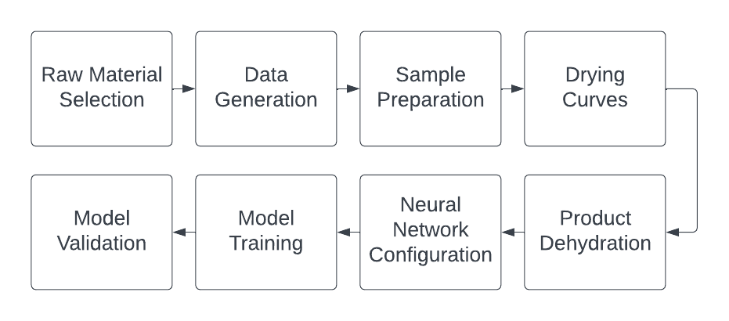

Source: Own elaboration based on (Gomez, 2019)

* **Raw Material Selection:** This process aimed to obtain tomatoes with uniform color and shape. Fresh saladette tomatoes (solanum lycopersicum), procured from a local supermarket, were selected as the raw material. The chosen tomatoes exhibited a vibrant red color, were free of surface blemishes, and displayed visual indicators of optimal ripeness. Additionally, they were visually assessed to be of uniform size. In preparation for processing, each tomato was thoroughly washed with soap and water to remove any adhering particulate matter, followed by disinfection with a bactericidal agent.

**Figure 2.** Raw Material

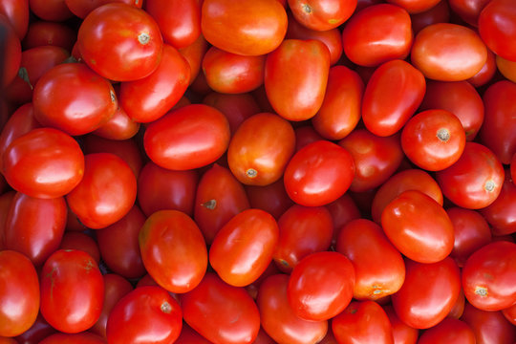

Source: Own Elaboration

* Data generation: An industrial air convection oven was rented, equipped with internal temperature sensors and a humidity sensor at the outlet. Data was transmitted to a computer, which recorded the information used for training the neural network. The temperature recorded corresponded to the interior of the oven, and the humidity was measured as relative humidity at the oven’s exit. The oven was equipped with a thermocouple with an accuracy of ±0.5°C for temperature sensing, an anemometer with an accuracy of ±0.1 m/s to measure air velocity, and a capacitive sensor with an accuracy of ±3% RH for monitoring relative humidity. The oven’s core incorporated a microcontroller that received data from these sensors and regulated both the temperature and air velocity generated by electric heaters and fans. Due to rental conditions, further technical details could not be disclosed.
* Tomatoes sample preparation: Three groups of saladette tomatoes (*Solanum lycopersicum*), each weighing 1 kilogram (for a total of 3 kilograms), were used. Each group was dried at a different temperature: 45°C, 50°C, and 55°C. Each kilogram was then divided into three subgroups with different slice thicknesses: 0.75 mm, 1.5 mm, and 3 mm.

**Figure 3.** Sample Preparation

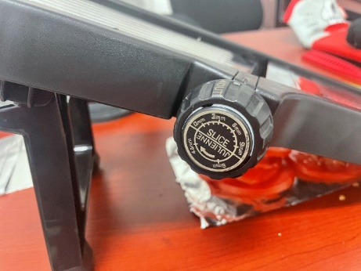

Source: Own Elaboration

A digital caliper was used to verify slice thickness, and a measuring tape confirmed the dimensions of each slice. To ensure consistent and uniform slices, a mandoline with adjustable thickness was used.

**Figure 4.** Sample Preparation

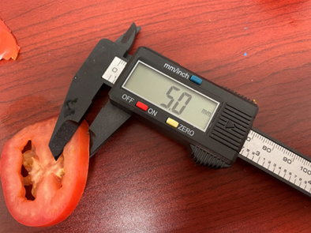

Source: Own Elaboration

* Obtaining drying data.: Each of the three groups of one kilogram was dried at the three distinct temperatures mentioned above (45°C, 50°C, and 55°C). The drying process continued until the relative humidity (%RH) at the oven’s exit reached between 16% and 20%. The final dataset was then randomly partitioned into two halves, each containing input and output vectors. The first half was designated as the training dataset, while the second half served as the testing dataset. The training dataset was utilized to train the model, while the testing dataset validated the trained model by comparing predicted outputs against actual data, assessing the model's accuracy and generalization capabilities. (Please see appendix A)
* Artificial neural network configuration: The neural network architecture consisted of an input layer with a single neuron, followed by two hidden layers with three neurons each, and an output layer with a varying number of neurons, depending on the specific task (Fuentes G., 2023).

**Figure 5.** ANN Configuration

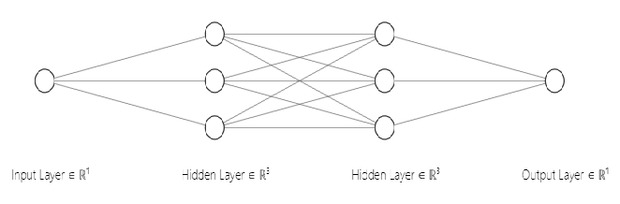

Source: Own Elaboration with NN SVG

* Obtaining the model through the Neural Network: The neural network training used the dataset described in the previous step, which was employed to estimate the model parameters corresponding to the underlying equation. Upon completion of training, the trend of the loss function over time was observed as the model minimized error, ultimately converging to a final loss value close to zero.

**Figure 6.** Loss Function

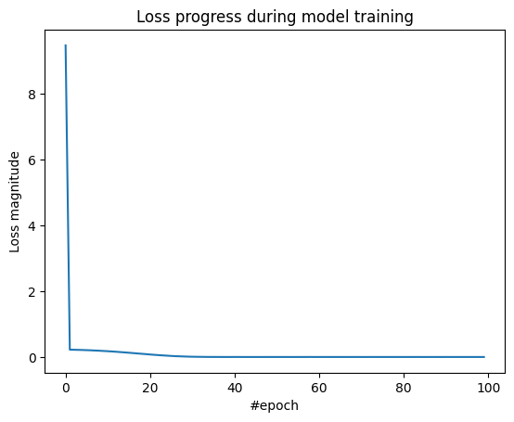

Source: Own Elaboration

* Weight Change Calculation Equation: The equation used to calculate the proportion of weight change with respect to relative humidity during the dehydration process took into account the relative humidity of the material:

As:

* + 1. = proportion of weight change
 $w_{i}=initial weight$

 $∆\%HR$  2. = relative humidity percentage during a dehydration process

$H_{d}=desired humidity in product$

This equation assumed that weight loss was primarily due to water removal, with negligible contributions from other factors, such as the loss of volatile compounds. Additionally, it assumed a linear relationship between moisture loss and weight change (Fuentes G., 2023). While this equation did not directly calculate weight change, it effectively targeted a relative humidity level of 16% in tomatoes, a commonly used benchmark in food processing. (Fuentes G., 2023).

* Quantification of Phenolic Compounds: To evaluate the effect of dehydration temperature and slice thickness on nutrient content, a quantification of phenolic compounds was conducted. Phenolic compounds in tomatoes encompass various phytochemicals, including flavonoids, phenolic acids, and tannins, which are vital for plant physiology and defense, as well as for human health due to their antioxidant and anti-inflammatory properties. The concentration of phenolic compounds was quantified in terms of gallic acid equivalents (mg GAE/g dry basis) using a gallic acid calibration curve. Tests were outsourced to a certified private laboratory for accuracy. Following the experimental setup described in Section 2, a total of 3 kg of tomatoes were prepared for dehydration. Each kilogram was dehydrated at different temperatures and subdivided into three groups based on slice thickness (0.75 mm, 1.5 mm, and 3 mm), as shown in Table 1.

**Table 1.** Process Parameters for Tomato Dehydration Trials

|  |  |  |  |  |
| --- | --- | --- | --- | --- |
| Temperature (ͦ C) | Sample  thickness | Time  (seconds) | Time  (Hours) | %Relative  humidity (%HR) |
| 45 | 0.75 | 6650 | 1.84 | 20.7 |
| 45 | 1.5 | 7100 | 1.97 | 20.4 |
| 45 | 3.0 | 7873 | 2.20 | 19.6 |
| 50 | 0.75 | 6784 | 1.84 | 16.9 |
| 50 | 1.5 | 7050 | 2.00 | 16.6 |
| 50 | 3.0 | 7334 | 2.03 | 15.9 |
| 55 | 0.75 | 5650 | 1.56 | 17.5 |
| 55 | 1.5 | 6500 | 1.80 | 16.9 |
| 55 | 3.0 | 7196 | 1.90 | 16.40 |

Source: Own Elaboration

* Sensory Panel Evaluation: A sensory panel was conducted to assess texture, aroma, color, and flavor. This panel consisted of five experts, all professionals with substantial experience in food-related fields, including chefs and food industry specialists.

The sensory panel followed a structured protocol in a controlled setting. Participants were seated in individual tasting booths under neutral lighting to minimize visual biases. Each expert received standardized evaluation sheets to record their perceptions, which included the following:

1. Hedonic Scale: Experts rated the overall acceptability on a 5-point scale (1 = ‘strong dislike’, 5 = ‘strong preference’).
2. Texture Profile Test: A texture profile test was conducted to evaluate key textural attributes: hardness, chewiness, and elasticity. These attributes were rated on a 5-point scale, with 1 representing "does not meet the attribute" and 5 indicating "fully meets the texture attribute."
3. Quantitative Descriptive Analysis (QDA): Experts assessed the intensity of key sensory attributes, including sweetness, acidity, and tomato flavor. Each attribute was rated on a 5-point numerical scale, where 1 signified "does not possess the attribute" and 5 represented "fully possesses the attribute."

**Results**

* Verification of the artificial neural network training: As shown in Figure 7, the time evolution of the model's estimated data closely aligns with the real data. The mean squared error between these two datasets is 0.04.

**Figure 7.** Model Validation.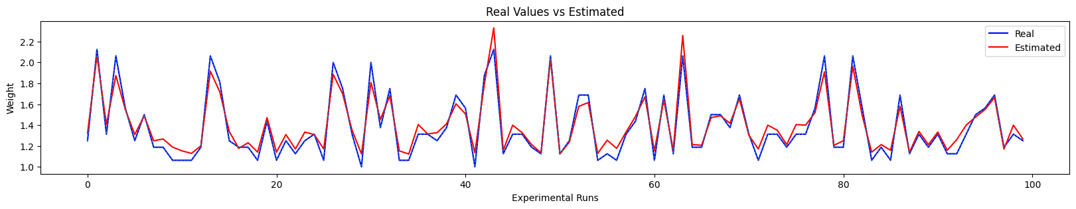

Source: Own Elaboration

* Tomato dehydration organoleptic results: The visual outcomes of the tomato dehydration process are illustrated in Figures 8, where distinct differences in color among the three samples are evident. The images on the left correspond to samples dehydrated at lower temperatures. As reported in relevant literature, color is closely linked to the concentration of lycopene and other essential nutrients.

**Figure 8.** Loss of Color and Mass.

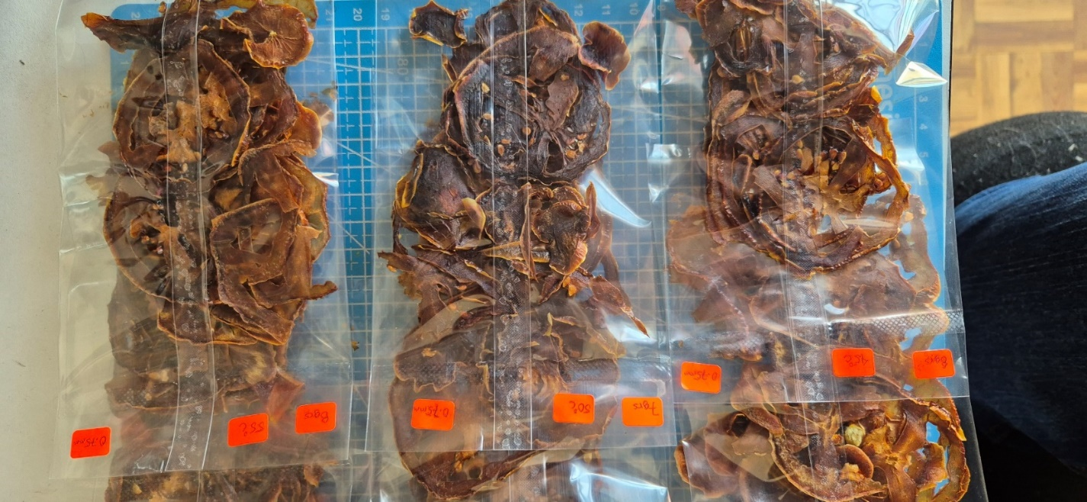

Source: Own Elaboration

The panel's evaluation indicated that tomato samples dehydrated at 50°C, regardless of thickness, were the most favored. Samples dehydrated at 55°C were slightly less preferred, whereas those dehydrated at 45°C received the lowest scores. Figure 9 presents these results.

**Figure 9.** Effect of Temperature (45, 50, 55 ͦ C) and Slice Thickness (0.75, 1.5, 3.0 mm)

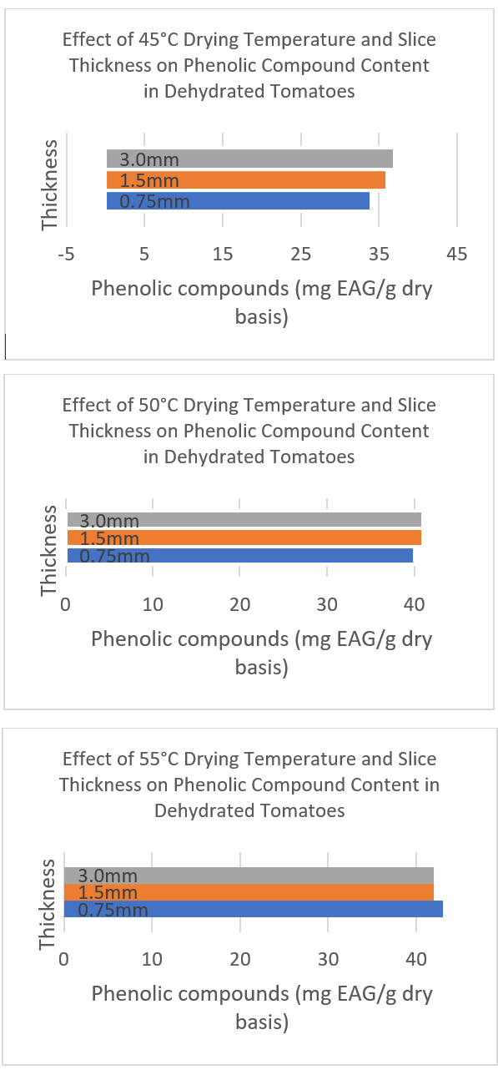

Source: Own Elaboration

* Behavior of Variables: Measurements of the variables were recorded every second. The collected data captures the temporal evolution of temperature, airflow at the oven’s outlet, and the relative humidity percentage of the product (Figures 10-11). "TD" (Target Dryer Temperature) refers to the target temperature maintained within the dryer chamber throughout the dehydration process, measured in degrees Celsius (°C) (Figure 12).

**Figure 10.** Relative Humidity Behavior

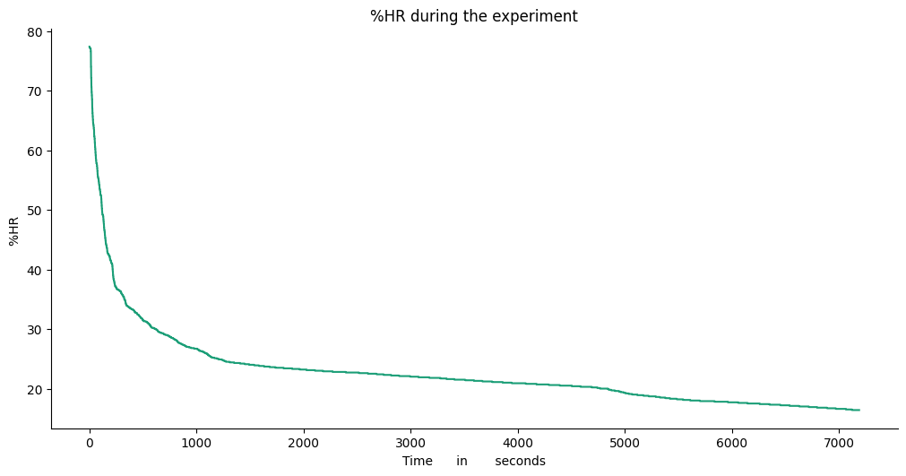

Source: Own Elaboration

**Figure 11.** Temperature Behavior

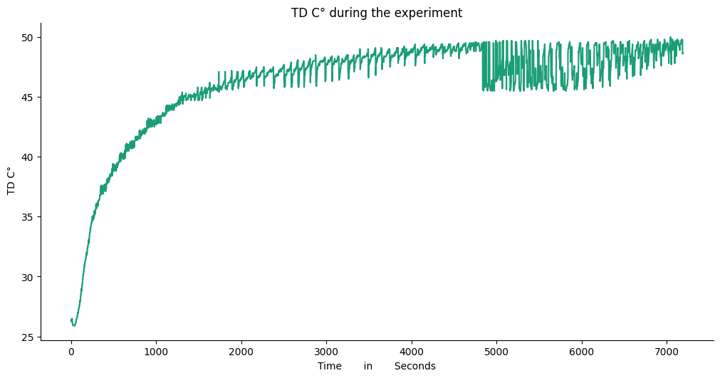

Source: Own Elaboration

**Discussion**

The primary goal of nutrition is to provide the body with the sustenance required for optimal growth and development. However, human culinary practices, driven by the pursuit of flavor and texture, often prioritize palatability over nutritional value (Degwale, 2022).

Fuentes (2023) presents a training model using the evolution of tomato weight over time. This methodology presents certain challenges, as temperature fluctuations occur during the process due to tomato weight measurements. The advantages of the present study lie in the indirect measurement of tomato humidity, ensuring compliance with the humidity and nutritional requirements demonstrated by laboratory results.

This research aims to identify the balance between nutrient content and sensory appeal, utilizing this data to train a neural network model. Studies by Degwale (2022), Yegrem (2022) and Umeohia (2024) focus on nutritional properties, exploring dehydration techniques, packaging, and other conditions to optimize nutrient retention in dehydrated tomatoes and other product. Most of this data is used to train artificial intelligence models for dehydration machines. However, no reports integrate organoleptic data into AI training to optimize its performance.

As observed in the temperature and thickness datasets, the impact on nutrient levels, though detectable, is not substantial but remains significant. This is significant as it indicates that despite variations in thickness and temperature, the nutritional composition remains relatively consistent with %HR as the principal goal, (remember that 16 % HR is the principal reference to the dehydration process). Concerning organoleptic properties, the diner's preference was to get samples at 50 degrees Celsius. With these results, the data for the artificial neural network training is selected and can be implemented in the oven and not using the weight data measurements through the process as (Fuentes G., 2023).

Future research could investigate the temporal evolution of the equipment's electric power consumption, incorporating relative humidity measurements alongside organoleptic and nutritional properties presented in this work. This multi-dimensional dataset could then be used to further refine and optimize the training process for an artificial neural network model to achieve not only the nutritional and industry requirements but also organoleptic properties, important for the diners’ consumers.

**Conclusions**

This research highlights the potential of artificial intelligence (AI), specifically using ANNs, to optimize the fruit dehydration process. By focusing on the critical parameter of relative humidity (%RH), the study demonstrates that it is possible to achieve consistent dehydration results while preserving nutritional content, even when varying factors such as temperature and slice thickness. The developed ANN model, trained on data collected from tomato dehydration experiments, accurately predicted the relationship between %RH and weight change, showcasing the efficacy of AI in modeling complex food processing dynamics. The findings further highlight the delicate balance between nutritional quality and sensory attributes in food processing. While higher dehydration temperatures might lead to faster processing times, they could also negatively impact nutrient levels and sensory appeal. The study's organoleptic tests revealed a preference for tomatoes dehydrated at 50°C, suggesting an optimal temperature range indicating an optimal temperature range that maintains both nutritional quality and sensory appeal. The integration of AI into food dehydration processes holds promising implications for the future. By enabling precise control over %RH and other critical parameters, AI can facilitate automation, enhance product quality, and potentially reduce energy consumption. The ability to predict and control dehydration outcomes based on real-time data can lead to significant advancements in food processing efficiency and sustainability.

Future research directions include expanding the scope of data collection to encompass the temporal evolution of dehydration equipment and incorporating measurements of %RH alongside organoleptic and nutritional properties. The resulting multi-dimensional datasets can be leveraged to refine ANN models further, enabling even more precise control and optimization of dehydration processes. The continued exploration of AI's potential in food science and technology is crucial for addressing the challenges of food security, sustainability, and nutritional quality in an ever-evolving global landscape.

**Future research directions**

Future research should focus on integrating artificial intelligence (AI) into embedded systems for real-time monitoring and autonomous control of the drying process, optimizing energy consumption and enhancing efficiency through microcontroller-based implementations. Additionally, expanding AI applications to the dehydration of other food products, such as mangoes, bananas, and chili peppers, will allow for comparative analyses of drying dynamics and nutrient retention across different food matrices. The incorporation of multidimensional data, including real-time measurements of temperature, humidity, color, and texture, will improve model accuracy, particularly through the use of advanced deep learning architectures such as recurrent neural networks (RNNs). Furthermore, the development of explainable AI (XAI) models will enhance interpretability and provide insights into key dehydration parameters, facilitating the implementation of hybrid approaches that combine neural networks with physical drying models. Lastly, the automation of the drying process using AI-driven control systems, coupled with computer vision for real-time quality assessment, holds significant potential to optimize both product quality and energy efficiency in industrial food processing.

**Acknowledgments**

The authors would like to express their gratitude to CONAHCYT for its support in promoting research and scientific advancement. We also extend our appreciation to the Tecnológico Nacional de México for its commitment and facilitation of research projects at the Instituto Tecnológico de Cd. Juárez and the Instituto Tecnológico Superior de Xalapa.

**References**

Alaloul, W. S. (2020). Data processing using artificial neural networks. Dynamic data assimilation-beating the uncertainties. IntechOpen. https://doi.org/10.5772/intechopen.91935

Anaya, M. M. (2017). Estado actual de los desperdicios de frutas y verduras en Colombia. Memorias De Congresos UTP, 194-201. Recuperado a partir de https://revistas.utp.ac.pa/index.php/memoutp/article/view/1493

Benítez, R., Escudero, G., Kanaan, S., & Rodó, D.M. (2014). Inteligencia artificial avanzada. Editorial UOC. https://openaccess.uoc.edu/bitstream/10609/140427/8/Inteligencia%20artificial%20avanzada_M%C3%B3dulo%201_Inteligencia%20artificial%20avanzada.pdf

Doymaz, I. (2007). Air-drying characteristics of tomatoes. Journal of Food Engineering, 1291-1297. https://doi.org/10.1016/j.jfoodeng.2005.12.047

Degwale, A., Asrat, F., Eniyew, K., Asres, D., Tesfa, T., & Ayalew, A. (2022). Influence of Dehydration Temperature and Time on Physicochemical Properties of Tomato (Solanum lycopersicum L.) Powder. Frontiers in Sustainable Food Systems.

Espinosa, N. V.-C.-M.-B. (2023). Modelado dinámico y control del proceso de secado de productos agroindustriales. La Mecatrónica en México, 1-16. https://www.mecamex.net/revistas/LMEM/revistas/LMEM-V12-N02-01.pdf

Fuentes G., G. O. (2023). Aprovechando la inteligencia artificial como herramienta metodológica para la optimización del proceso de deshidratación de tomate. In Varios, Optimización, sustentabilidad y políticas públicas: un enfoque robusto (pp. 92-106). CENID. https://doi.org/10.23913/9786078830244

Gómez, M. (2019). Deshidratado de tomate saladette en un secador de charolas giratorias. [tesis Universidad tecnológica de la Mixteca ] Huajapan de León, Oaxaca, México. http://jupiter.utm.mx/~tesis_dig/10991.pdf

Gustavsson, J. C. (2011). J., Cederberg, C., Sonesson, U., Van Otterdijk, R., & Meybeck, A. (2011). Global food losses and food waste. Düsseldorf.

Khan, M. I. (2022). Application of machine learning-based approach in food drying: Opportunities and challenges. Drying Technology, 1051-1067. https://doi.org/10.1080/07373937.2020.1853152

Flórez, R., & Fernández, J. (2008). Las redes neuronales artificiales, fundamentos teoricos y aplicaciones practicas. España, Netbiblo.

Madhankumar, S., Viswanathan, K., Taipabu, M. I., & Wu, W. (2023). A review on the latest developments in solar dryer technologies for food drying process. Sustainable Energy Technologies and Assessments, 58, Article 103298. https://doi.org/10.1016/j.seta.2023.103298

Monsalve, J. &. (2007). Evaluación de dos métodos de deshidratación del tomate (Lycopersicom esculentum mill) variedad manzano. Multiciencias, 7(3), 256-265.

Mordor Intelligence. (n.d.). Dehydrated food market size. Retrieved October 28, 2024, from https://www.mordorintelligence.com/industry-reports/dehydrated-food-market/market-size

Secretaría de Agricultura y Desarrollo Rural. (s.f.). ¿A qué nos referimos con autosuficiencia alimentaria? Gobierno de México. Retrieved October 28, 2024, from https://www.gob.mx/agricultura/colima/articulos/a-que-nos-referimos-con-autosuficiencia-alimentaria-235470?idiom=es

Sengkhamparn, N. &. (2019). Phenolic compound extraction from industrial tomato waste by ultrasound-assisted extraction. Conference series: materials science and engineering (Vol. 639, No. 1), 012040. https://doi.org/10.1088/1757-899X/639/1/012040

Sullivan, V. K.-E. (2020). Dried fruit consumption and cardiometabolic health: a randomised crossover trial. . British Journal of Nutrition, 2020 Nov 14; 124(9), 912-921. https://doi.org/10.1017/S0007114520002007.

Yegrem, L., Mengestu, D., Legesse, O., Abebe, W., & Girma, N. (2022). Nutritional compositions and functional properties of New Ethiopian chickpea varieties: Effects of variety, grown environment and season. International Journal of Food Properties, 25(1), 1485–1497. https://doi.org/10.1080/10942912.2022.2087674

**Appendix A**

**Figure 12.** Example of dataset entries used for training the neural network.

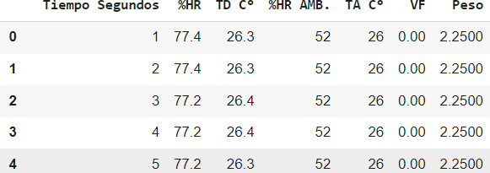

Source: Own Elaboration

**Figure 13.** Python code for configuring and training the recurrent neural network (RNN).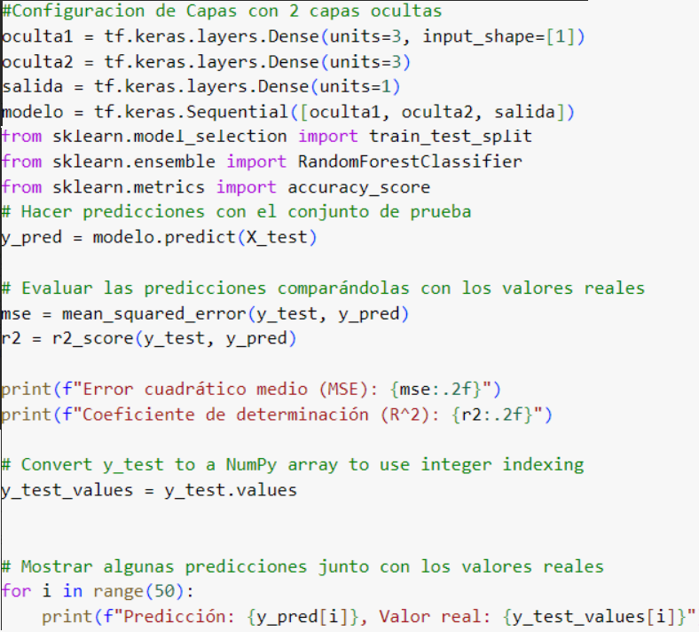

Source: Own Elaboration

|  |  |
| --- | --- |
| Rol de Contribución | Autor (es) |
| Conceptualización | Gabriela Fuentes (Igual), Octavio García (Igual), Adán Valles (que apoya) |
| Metodología | Gabriela Fuentes (Igual), Octavio García Valles (Igual), Adán Valles (que apoya) |
| Software | Gabriela Fuentes (Principal), Octavio García (que apoya) |
| Validación | Gabriela Fuentes (Principal), Octavio García (que apoya) |
| Análisis Formal | Gabriela Fuentes (Principal), Octavio García (que apoya) |
| Investigación | Gabriela Fuentes (Igual), Octavio García (Igual) |
| Recursos | Gabriela Fuentes (Igual), Octavio García (Igual) |
| Curación de datos | Gabriela Fuentes (Principal), Octavio García (que apoya) |
| Escritura - Preparación del borrador original | Gabriela Fuentes (Principal), Octavio García (que apoya) |
| Escritura - Revisión y edición | Gabriela Fuentes (Principal), Octavio García (que apoya) |
| Visualización | Gabriela Fuentes (Principal), Octavio García (que apoya) |
| Supervisión | Gabriela Fuentes (Principal), Octavio García (que apoya) |
| Administración de Proyectos | Gabriela Fuentes (Principal), Octavio García (que apoya), Adán Valles (que apoya) |
| Adquisición de fondos | Gabriela Fuentes (Principal), |