https://doi.org/10.23913/ride.v12i23.1060
Artículos científicos
Why use WhatsApp? college graduates answers in Mexico, a personal mass communication proposal
¿Por qué usar Whatsapp? responden egresados universitarios en México, una propuesta de comunicación personal masiva
Por que usar o Whatsapp? graduados da universidade respondem no México, uma massiva proposta de comunicação pessoal

José Luis Bordas-Beltrán
Universidad Autónoma de Chihuahua, México
jbordas@uach.mx
https://orcid.org/0000-0003-1465-3662

Ana María de Guadalupe Arras-Vota
Universidad Autónoma de Chihuahua, México
aarras@uach.mx
https://orcid.org/0000-0002-4115-9646

Damián Aarón Porras Flores
Universidad Autónoma de Chihuahua, México
dporras@uach.mx
https://orcid.org/0000-0001-9536-4007

María del Carmen Gutiérrez-Diez
Universidad Autónoma de Chihuahua, México
cgutierr@uach.mx
https://orcid.org/0000-0001-9159-3283

Abstract
The way in which the communication process is carried out has evolved over time, as has our ability to adapt to it and use it as one more tool of our natural way of relating every day. This study seeks to analyze how individuals from Mexico value the use of WhatsApp (WA), by age and gender, as well as the time and reasons that lead them to use the mobile instant messaging (MIM) application. The method used is applied research, of a field and descriptive mode, using the following methods: analytic-synthetic and deductive theoretical. The research techniques used were bibliographic, surveys and structured interviews, applied to a sample of 237 WA users in Mexico. The results were analyzed with the SPSS and ATLAS packages. The analysis and interpretation of the information allows for identifying that WA’s most valued characteristics are its function as a mean of communication, its speed, and ease of use. The least valued attributes are junk information, distraction and seeing it as a waste of time. In addition, the younger people are, the more time they spend using WA. In addition, the study presents an Axiological and Teleological model of WA as perceived by users, as well as a Personal Mass Communication Model. Understanding that WA is valued as a fast and easy-to-use personal mass communication means allows groups, companies and organizations, including MIM applications, to use it as a channel of information to establish contact and send messages that generate direct interpersonal relationships with those groups that they intend to reach.

Keywords: WhatsApp; personal mass communication; social networks; identity; culture.

Resumen

La forma en el cual el proceso de comunicación se realiza ha ido evolucionando con el paso del tiempo, al igual que nuestra capacidad para adaptarnos a ello y utilizarlo como una herramienta más de nuestra forma natural de relacionarnos día con día. Por lo tanto, el presente estudio busca analizar la forma en que las personas en México valoran el uso del WhatsApp, por edad y género, así como el tiempo y los motivos que los llevan a utilizar la aplicación de mensajería instantánea (MI). La investigación es aplicada, de campo y descriptiva, utiliza los métodos: analítico sintético y teórico deductivo. Las técnicas de investigación utilizadas fueron bibliográficas, encuestas y entrevista estructurada, aplicada a una muestra de 237 usuarios de WA en México. Además, los resultados se analizaron con los paquetes SPSS y ATLAS. El análisis e interpretación de la información permite identificar que lo más valorado de WA, por las personas en México, es su función como medio de comunicación, la rapidez, y facilidad de uso y lo menos valorado es la información basura, la distracción y lo que aducen como robo de tiempo. Además, mientras más jóvenes son las personas es mayor el tiempo que dedican al uso de WA. Adicionalmente, el estudio presenta un modelo axiológico y teleológico sobre la percepción que tienen los usuarios sobre el WA, así como un modelo de Comunicación Personal Masiva. Comprender que el WA es valorado como medio de comunicación personal masiva rápida y fácil de utilizar permite que tanto grupos, empresas y organizaciones, de diversos giros, entre ellos de aplicaciones MI, lo puedan utilizar como canal de información para establecer contacto y enviar mensajes que generen relaciones interpersonales directas con aquellos a los que se pretende alcanzar.
Palabras clave: WhatsApp, comunicación personal masiva, redes sociales, identidad, cultura.

Resumo
A forma como o processo de comunicação é realizado tem evoluído ao longo do tempo, bem como a nossa capacidade de a adaptarmos e a utilizamos como mais uma ferramenta da nossa forma natural de nos relacionarmos todos os dias. Portanto, este estudo busca analisar a forma como as pessoas no México valorizam o uso do WhatsApp, por idade e sexo, bem como o tempo e os motivos que os levam a usar o aplicativo de mensagens instantâneas (MI). A pesquisa é aplicada, de campo e descritiva, utiliza os métodos: analítico sintético e teórico dedutivo. As técnicas de pesquisa utilizadas foram bibliográficas, levantamentos e entrevistas estruturadas, aplicadas a uma amostra de 237 usuários de WA no México. Além disso, os resultados foram analisados ​​com os pacotes SPSS e ATLAS. A análise e interpretação da informação permite-nos identificar que o mais valorizado da WA, pelos mexicanos, é a sua função de meio de comunicação, rapidez e facilidade de utilização e o menos valorizado é a informação lixo, distração e qual eles reivindicar como roubo de tempo. Além disso, quanto mais jovens são, mais tempo passam usando WA. Além disso, o estudo apresenta um modelo axiológico e teleológico sobre a perceção que os usuários têm sobre a CT, bem como um modelo de Comunicação Pessoal de Massa. Entender que WA é valorizado como um meio de comunicação pessoal de massa rápido e fácil de usar permite que grupos, empresas e organizações, de vários tipos, incluindo aplicativos de MI, utilizem-no como um canal de informação para estabelecer contato e enviar mensagens que gerem relacionamento interpessoal com aqueles que você deseja alcançar.
Palavras-Chave: WhatsApp, comunicação pessoal de massa, redes sociais, identidade, cultura.
Fecha Recepción: Marzo 2021 Fecha Aceptación: Octubre 2021

Introduction
Nowadays, with the development of technologies it is possible for humans to be as close to each other as the distance from their eyes to the palm of their hand, because through a mobile device one can establish contact and a conversation with people who are physically located miles away on the planet. McLuhan & Powers (1995), proposed that the world had been reduced to the size of a village through the media of the time, such as television, radio, cinema, telegraph, telephone, among them to send stickers and audio or video messages, and also allowing for live conversations (videoconferences) (Dans, González-Sanmamed, & Muñoz-Carril, 2019; Fondevila-Gascó, Marqués-Pascual, Mir-Bernal & Polo-López, 2019), therefore people in this era have new means of communicating and sharing meaning through MIM.
The paper begins with a discussion of the current state of knowledge in relation to the concept of human communications among users of technology and the construction of identity through new forms of relations among WA users in Mexico, which are sustained in an axiology and a telos; followed by an overview of the methodology. The “analysis and findings” section describes the constitution of the sample of college graduates in terms of gender and age; it also pinpoints that the App can become a barrier for personal face-to-face communications. Also, it is a conceptual model related to the axiology and telos of WA users. In addition, the study presents a Personal Mass Communication Model. Finally, the paper discusses these results and considers their implications for organizational communications.

Theoretical Framework
"Communication technology has become a very important element around the globe. It is considered more of a necessity than a luxury. The widespread use of mobile phones, the Internet, Facebook, WA and Twitter have brought increasing acceptance in virtually all social situations. Calls and messages are no longer considered interruptions to the main activity that takes place but are considered important communications. Proximity is becoming inconsequential in terms of social interaction” (Shahin, 2019).
Furthermore, boundaries between interpersonal and mass communication have blurred in such a way that they allow people to communicate with groups that used to be too large (Baym, 2015). These events have generated conceptual changes in communication, since the process of exchanging messages face-to-face is added to that of mass personal communication, which refers to the interactions that are made through the various virtual platforms, where more personal relationships can be given according to response patterns from receptors (French & Bazarova, 2017) and from the ways in which people relate to each other. This can lead one to think in terms of a face-to-screen-to-face personal communication. Also, Baym (2015) points out that when communicating on digital media, people manifest themselves as individuals, groups or societies. In this interpersonal exchange that is generated through words, conversations, stories, metaphors, images and more, participants negotiate the meaning of relationships and what is desired of them. Then one can say, according to Boyd (2010) that technology networks reorganize the ways in which information flows and the ways in which people interact with and between each other, to which may be added that it is the subject of communication which decides how he or she uses Information Communication Technology (ICT) and with whom they relate. In these new spaces of communication people inject, according to Baym (2015), amiability, express emotions, closeness and availability, while having fun and building new social structures. For the author, the mediated interaction should be considered more than as a diminished form of incarnate interaction, a new mixed and eclectic modality that combines elements of face-to-face communication with written elements and images, as well as expressions of nonverbal language and through them, social identities that transcend media, including gender and culture, can be potentially reshaped.
This leads to considering that through modern media and the daily interrelationships that are developed in various spaces, one of them that of social networks, the being is redefined. Since identity is constituted as the unit of definition of human beings, which determines itself as a unique and unrepeatable being, who can distinguish what makes her or him different from others. To the extent that when she/he recognizes what individualizes her/him, they have the ability to recognize the other. This opens the possibility of determining the dialectic between one´s self and the community, dialectic that determines the nature and qualities of the same being and his relationship with the environment, including other beings and their ways of being (Rivera-Plata, 2018).
This dialogical action in which the being recognizes herself/himself and the other or others, leads to considering identity a relational and dialogical process (Guitart, Nadal & Vila, 2010; Marcus, 2011; Rivera Sanin, 2016;), that always develops in relation to the other or others (Marcus, 2011), within a social structure. So one can say that identity is constituted as a regulatory apparatus for social practices (Rivera-Plata, 2018), that are part of the culture of human groups which is transmitted through communication. In fact communication, power and culture are considered to be concomitant and interdependent processes with each other (Arras Vota, 2010), and contribute to the survival of society and the adaptation of individuals (Kluckhohn, 1971) to it.
As previously stated, at present the ways of communication and the means for carrying it out have increased, the existence of virtual resources for interactions has increased the number and kind of people communicating with each other (Velarde, Bernete & Casas-Más, 2019) and, with it, the interactive processes of people using them. The creation of social networks has opened up virtual spaces where human beings meet and contact each other, they talk, they agree or disagree, they share their experiences, remember and identify with each other. One of the applications that has built this site that is a meeting point is WA, which refers to one of the virtual spaces of communication that since 2009, has facilitated the exchange of instant messages, images, videos and voice calls over an Internet connection, which has been installed, more than half a billion times on smartphones worldwide (Montag , et al., 2015).
Recently it has been discovered that the most popular social networks worldwide, according to the number of active users, are Facebook, which exceeded 2.3 billion active monthly users, while WA had 1.6 (STATISTA, 2019).
In Mexico in 2018, 73.5% of the population aged six years or older used a cell phone. Of these, eight out of ten users had a smart cell phone (Smartphone) which allowed them to connect to the Internet. The total number of users with a smart cell phone (Smartphone) grew from 64.7 million people in 2017 to 69.6 million in 2018. In addition, in 2018 there was an increase in users who connected to the internet from a smart cell phone (Smartphone), from 92.0% in 2017 to 93.4% in 2018; with a difference of 5.5 million people. Of the users of smartphones, 45.5 million installed applications on their phones: 89.5% instant messaging, 81.2% tools for access to social networks, 71.9% audio and video content apps, and 18.1% some app to access mobile banking. (El Instituto Nacional de Estadística y Geografía (INEGI), 2019).
When people chose WA which is a product that is used as a means of communication, they are assigning a meaning to the app which can lead one to think that they perceive it as a device that in terms of its use (Andersson & Samuelsson, 2019) creates value because it is functional, due to its performance, and it fulfills some of their social and emotional needs, derived from the feelings or affective states that it generates (Sweeney & Soutar, 2001). So in terms of WA use there is a purpose, a telos for its use from consumers’ perspective, and a value humans –the only being that has its own definition of itself (Hartman, 2011)- assigns to the app, so the formal frame of reference for value is formal axiology (Hartman, 2011), in terms of extrinsic, intrinsic and systemic value. ‘Extrinsic value’ reflects the utilitarian or instrumental use of a particular service as a means to a specific end, whereas ‘intrinsic value’ represents the emotional appreciation of the consumption.
The term ‘systemic value’ refers to the rational or logical aspects of the inherent relationships among concepts in their systematic interaction (Hartman, 2011). In this sense value is an aggregate concept made up of several components.
WA holding the 2nd place as a social network in use in Mexico (STATISTA a, 2020), and also, due to its rapid adoption by young people, is a form of communication worth analyzing (Vidales-Bolaño & Sádaba-Chalezquer, 2017) in different contexts where people assign value to the use of WA (Cruz-Cárdemas, et al., 2019). Correspondingly it is important to find out the patterns of WA users in various age ranges (Rosenfeld, Sina, Sarne, Avidov, Kraus, 2018). So taking into consideration all these elements, one may establish the purpose of this research, which is to describe the composition, gender and age of college graduates in Mexico that use WA and to analyze why they use it, and whether the use of this MIM interferes with their communication when being face-to-face with another person; the telos and axiological aspects that people consider they attain through the use of WA, the time they spend depending on their age ranges and also to find out from which device they access this App, whether it is through a Smartphone or a PC, all this to advance our understanding of human behavior in relation to MIMs. This because MIMs are a service/application whose social and physical context of use are of great importance (Cruz-Cárdemas, et al., 2019) at present.

Methodology
The research setting
The present study was conducted throughout the Mexican Republic. Mexico has an approximate population of 125,900,000 inhabitants (STATISTA b, 2020), of which 23% or 28,959,000 people have college educations (OECD) (Organización para la Cooperación y el Desarrollo Económicos (OECD), 2019). People with a college education in Mexico are the universe of study for this research. The sample collected was of 237 people between 20 and 70 years of age with a standard deviation of 5%. Our sample exceeds the 160 persons required by the following formula:
$$=\frac{z^{2}pqN}{E^{2}N+z^{2}pq}$$
The research developed is applied, of a descriptive and field mode. It also used the analytical-synthetic and deductive theoretical methods. Bibliographical techniques and surveys were given. Results were studied quantitatively and qualitatively, using statistical programs depending on the type of questions asked. Quantitative data was exported from Excel to SPPSS software to provide a statistical analysis (IBM, 2019). And qualitative information was analyzed through the ATLAS (ATLAS.ti, 2019) program with the purpose of constructing semantic nets.

The investigation comprised two phases as shown below in Figure 1:

Figure 1. Study Phases of WA use of college graduates in Mexico
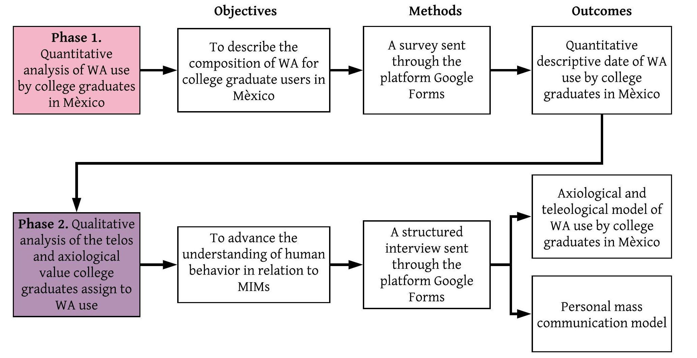
Source: Self Made

Hypothesis
For this research the following hypothesis were presented:
- H1 What people value most of the use of WA are relationships (De Vita Montiel, 2008), emotional support and ease of use (Cruz-Cárdemas, et al., 2019).
- H₂ The age of WA users influences the time spent using this app (Sankalp, Mohmmed & Kantharia, 2015).
- H₃ WA users consider this App interferes with their personal communications (Sankalp, et al., 2015).

Tools used for the collection of information
Based on the purpose of the research, a survey was designed and sent through the platform Google Forms (Google, 2019), to WA (WhatsApp Inc. a, 2019) users.

Results
In order to build an image on the conformation of the universe of study, three tables are presented with information about the sex, age range and work area of the people who participated in the research work.

Quantitative
Sample composition by sex, age and area of work (Table 1):

Table 1. Sex of respondents
Sex | n | %
Female | 135 | 57
Male | 102 | 43
Source: Self Made
Results show that more women than men answered the survey.

Table 2. Age range of respondents
Age range | N | %
20 – 25 | 83 | 35
26 – 35 | 52 | 22
36 – 45 | 38 | 16
46 – 55 | 26 | 11
56 - 70 | 38 | 16
Source: Self Made
Table 2 shows 57% of respondents are younger than 36, which can be related to the use of WA by persons that are Millennials, and some can be from the Z generation (Dimock, 2019).

Frequency of WA use by sex
Information on the frequency of use of the WA network by sex will be included in the following Table 3:
Table 3. WA frequency of use
 |  |  |  |  | X²
 | Daily | Weekly | Monthly |  | Value | p
Female | 130 | 0 | 0 | 130 | 3.952 | 0.139
Male | 97 | 2 | 1 | 100
 | 227 | 2 | 1 | 230
Source: Self Made
Analysis indicates 230 [7 cases lost according to SPSS (2019)] that almost 97% (n = 227) of the people use WA every day. Statistical analysis (Table 3) shows a value for X² of 0.139, which means there is no significant difference between sex and frequency of use of WA by the people who participated in the study.

Devices used to access WA
For devices used to access WA, the following was found (Figure 2):

Figure 2. Device on which individuals in Mexico use WA
Source: Self Made
Figure 2 presents information regarding the device with which WA users access this social network. 58% connect via their smartphones, reflecting a 36% higher percentage than users accessing the WA on their PCs or Tablets; this finding calls for reflection, because the application of the WA Web is a tool that allows users to access this social network through the PC and / or Tablet with which they can expand the spectrum of use due to the ease of the possibility of transferring files, sustaining communication with different co-workers in a practical and productive way (WhatsApp Inc. b, 2019). It can be seen as an opportunity for the WA company to be more aggressive in promoting its services to be able to position itself as the number one app used in Mexico.

WA and interference with face-to-face personal communication
Another important aspect of the study is the result of the question about people's perceptions of WA interference in their communications when they are face-to-face with another individual. Figure 3 shows the percentage of answers given:

Figure 3. WA users’ perception regarding the constant use of the app and its interference with face-to-face communication
Source: Self Made
50% of users consider that WA (Figure 3) interferes with their interpersonal face-to-face communications; results are consistent with the findings of Sankalp et al. (2015), where respondents stated that "the use of Facebook and WA lead them to a lower participation in face-to-face interactions, less understanding, having false impressions about people, as well as relationships based more on the material and some unwanted communications." This can be related to the presence of a barrier or interference in communication, when WA use becomes a distraction tool that prevents attention from being paid to the people with whom a person comes into contact in a physical face-to-face relationship, or also through WA use.

Time spent using WA
Below the results of behavior this study found in relation to the time people between 20 and 70 years of age dedicated to WA use are presented.
Figure 4. Time spent using WA
Source: Self Made
53% of the people who participated in the study use WA more than 2 hours a day. This data can be related to the findings of Sankalp, et al. (2015), who inferred that young people, between the ages of 18 and 24, spend 3.09 hours, on average per day, on social media, one of them WA.
Figure 4 shows that the remaining 47% claim to spend between 0 and 2 hours in this application, which led to an analysis of the relationship between age and time spent by people on the WA social network (Figure 5) and found that younger people use WA the longest.
Subsequently, as the age of the subjects progresses, the use of this network decreases, however, the range of WA usage between 0 and 2 hours is mostly integrated by users aged 18 to 27 (f = 29), 28 – 37 (f = 29) and 58 – 67 (f = 30). The above is shown in Figure 5:

Figure 5. Frequency of WA use by age range
Source: Self Made
The linear correlation between the time used by WA users in relation to their age was found with a Pearson Coefficient (r). When p is positive, the relationship is direct between the variables. If p is negative, the relation is inverse, and if p = 0, variables are independent (Ostle, 1980). Results of correlation between age and time are presented in the following Table 4:
Table 4. Correlation values
r = -.328 | p = .000 | N = 235
Source: Self Made
A strong negative correlation is observed; which means that the older people are, the less time they spent using WA.

Qualitative
These results are showed in the following Figure 6:

Figure 6. Semantic network of what professionals’ value most and least about the use of WA
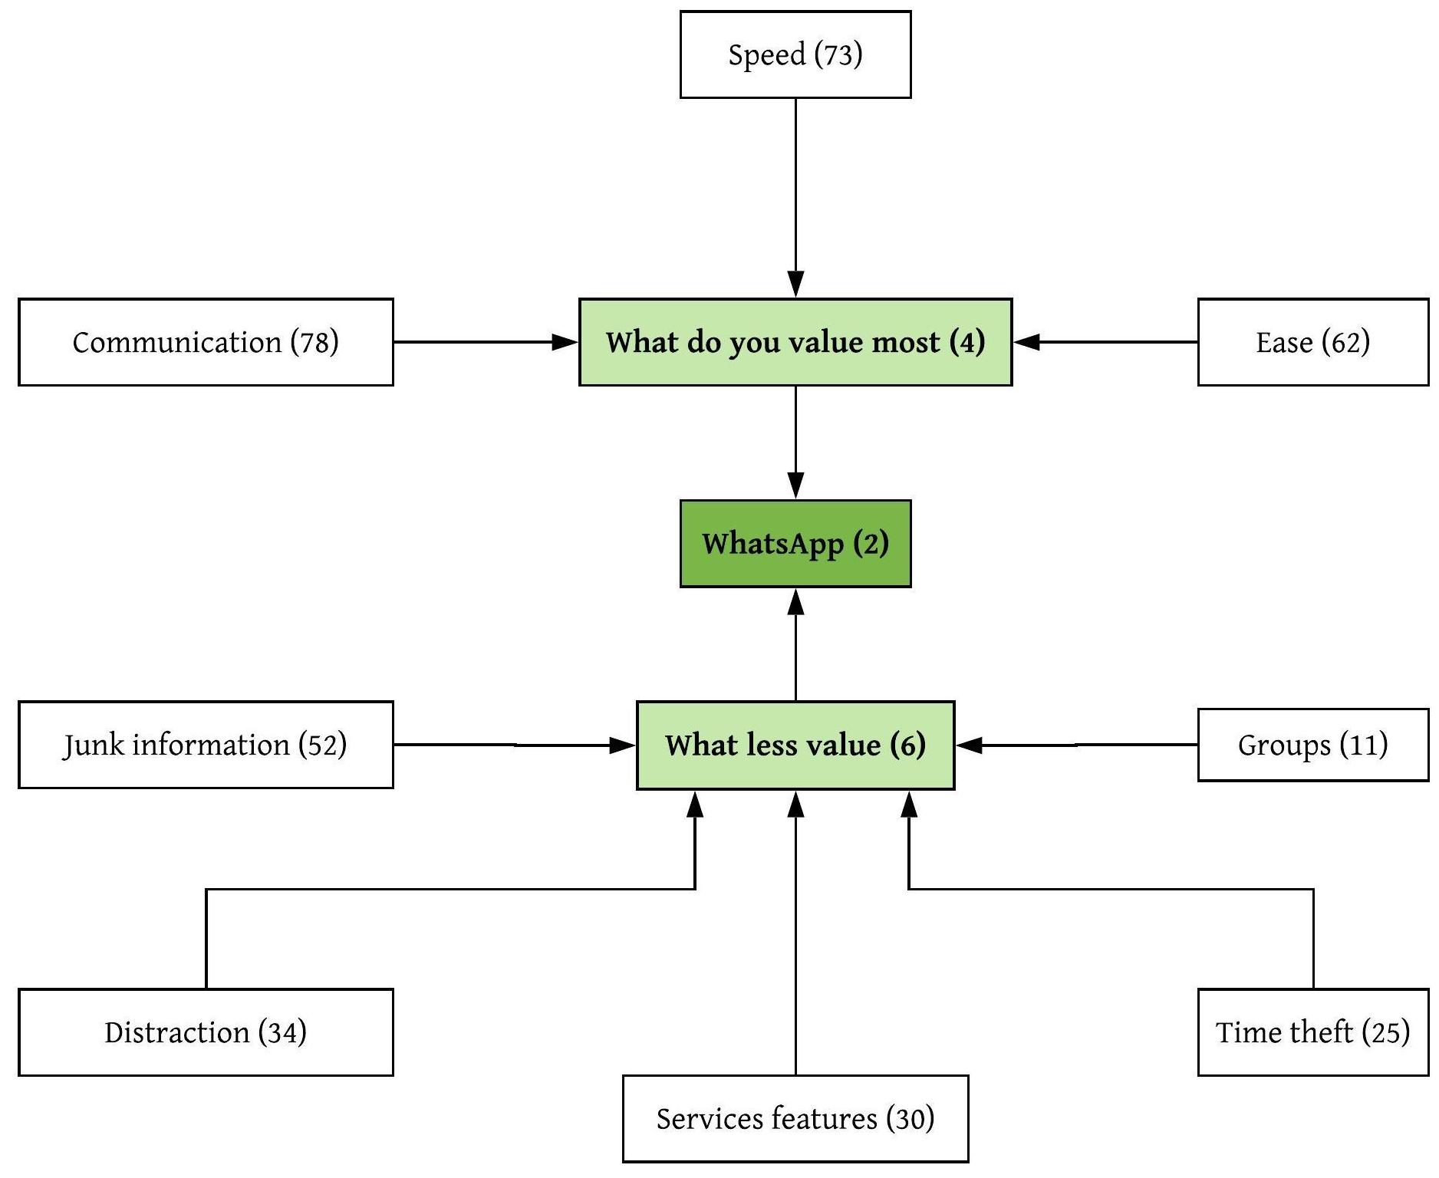
Source: Self Made
This can be observed in selected comments, which represent most answers expressed by persons who answered the Survey such as:
Personally, for my work it is an indispensable tool for staying in communication
I use WA to stay in touch with my family
The purpose of “…using WA is to keep in touch with my friends
People think that WA allowed them to access family, friends and people with whom they work, while replacing phone calls through the use of voice messages that they have recorded to replace written text. Also, there is extensive use of images and emoticons.
Users' responses regarding WA axiology is that people assign value to this app because it is an easy and fast way of communication (f=78), with anyone around the world. This Result coincides with Rubio Romero & Perlado Lamo de Espinosa (2015), who consider that, due to the deplopment of smart phones and their access to Internet, communication is mediated in a technological context, which in turn has positioned WhatsApp use in second place globally (STATISTA, 2019). Another factor that research participants value is Rapidity (f=73), as an advantage provided by Information and Communication Technologies (ICTs), which improve, among other things, the speed of communication and allows the parties involved in interaction to achieve their individual goals (De Vita Montiel, 2008). The third most valued aspect is the Ease in the use and understanding of this application (f= 62), sent by MIM, which coincides with what Tyrer found in his research (2019). Let’s hear the voice of the survey respondents in regard to aspects they value most when using WA:
The speed of communication and connectivity with everyone
Personally, for my work it is a super indispensable tool to be able to stay in communication
The ease of communicating and sending multimedia messages
The ease of being able to send messages to anyone since they all have WhatsApp
The fluidity of immediate communication and the ease of sharing information, documents etc.
It's an app that's always updated and has a fairly large number of users, which makes it very accessible for talking to anyone in the world
Being in touch with family and friends
Also, there are aspects not valued by WA users such as: receiving junk information (f = 52). As a matter of fact, there are studies that show that there is an increase in misinformation through the WA platform, especially among the age group that are between 19 and 24 years old. Therefore, society needs to stop the spread of fake news and explain the demerits that these entail (Khurana & Kumar, 2018). Another factor that users least value when using the WA is the distraction (f= 34), which is noted by Alonso, Bartolomé & Bartolomé (2016), that these types of networks generate, while under-cutting people's critical capacity. Likewise, people state that the characteristics of the service (f= 30) with respect to the display and functionality of the application are not to their complete satisfaction.
Just to pinpoint this aspect that demonstrates the aspects least valued by WA users a response given in the Survey is now presented: "Backups are complicated to download once I need to change the mobile. I can't keep messages and other content, or save my conversations".
Users comment that WA robs them of their time (f =25), a fact that is highlighted in tables 4 and 5 respectively in relation to the frequency of use of this application. In addition, some people express their dissatisfaction when another person incorporates them into a WA group without their consent, and is expressed as follows: "That I can be integrated into a group without my consent”
It is important to hear their voice manifested in the structured interviews in regard to aspects they value the least in relation to WA use:
Lack of privacy, wasted time, digital lockdown and fewer physical relationships
Sometimes too much unwanted information is received
Junk information in groups
Some groups are very annoying
The low level of users with critical thinking
Junk messages (images, audios, videos and texts, "chains"
Sending useless messages like images or memes and sending fake news

Discussion and Implications
The present study initiated with the purpose of analyzing what college graduates in Mexico who use WA value in this App, whether their age had an influence on the time they spent using the App, and if WA constitutes a barrier for personal communications. The evidence attained demonstrated that the main value for the use of WA is communication, that can be correlated to results found by Cruz-Cárdenas et al., (2019) and the ease of use considered by De Vita Montiel (2008), in his study. The new value ascribed in this scenario was WA’s rapidity.
Also, it can be said that the age of WA users influences the time they spend using this App (Sankalp, et al., 2015). Results showed that the younger the people are the more time they spend using WA.
And when considering WA as a mean of communication that allows people to be in touch and extends their relationships over distances and reunites groups and family, a contra part was discovered, because it was said, by 50% of respondents, that WA use can cause interference with personal communications. This can be seen as a barrier in personal mass communication, due to fake news, overload of information, and the presence of junk information.
Another finding is that the telos for using WA is for communication with friends and family. For 67% of the sample WA is a means that makes it easier for them to stay in touch with family, friends and co-workers. In this sense, if technologies are used to convey information and generate knowledge (Caro, 2017), as well as to communicate, act and interact with each other to apply intelligence to the processes of social construction, technology can be seen as an element that allows for the transformation of society. It was also found that there is no significant difference in the use of WA by gender in college graduates in Mexico. In addition, the patterns of behavior of society show the acceptance of ICT by all different age groups. Although it is true that young people devote more time to it, all groups, including senior groups use this tool to communicate by sending and receiving messages and thus, building relationships and exchanging their life processes through the virtual space where they are connected from the palm of their hand with their contacts around the planet.
Additionally, in the current context of isolation, WA has become the tool adopted par excellence by organizations to maintain contact and provide support for their clients and collaborators. It is a trend that is here to stay as part of this "new normal", in such a way that it is of utmost importance to understand its use and implications.
As for further research there is a task that remains such as to investigate the content that groups exchange through the WA social network, and to study diverse groups, including those that are not college graduates and the possibility of comparing results between both groups.

Figure 7. Axiological and Teleological model of WA as perceived by users
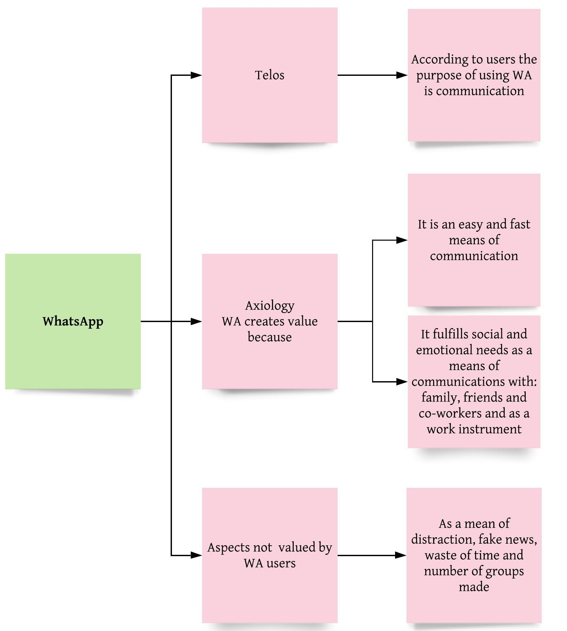

Source: Self Made
Figure 7 shows that WA is functional in terms of its telos: that is as a mean of communication. And it is valued as a mean of interaction and for its ease of use and for attaining results quickly. “Being in touch with family and friends.” Also according to the findings of this study WA can be used as a work instrument, which reflects the extrinsic value (Hartman, 2011) and it also allows people to fulfill social and emotional needs of relationships with family, friends and co-workers, aspect that reflects the emotional appreciation of consumption (Hartman, 2011).
Nevertheless, some of the respondents consider that it is a means of distraction and a barrier to communication due to fake news and the number of groups in which they participate. In this sense WA contributes to the conceptual change of face-to-face communication, to one of face-to-screen-to-face communication, that can be related to the concept of mass personal communication (Baym, 2015). The model of this is presented here and reflects the systemic value of both intrinsic and extrinsic values.

Figure 8. Personal mass communication model
ICT
APPS
Languages
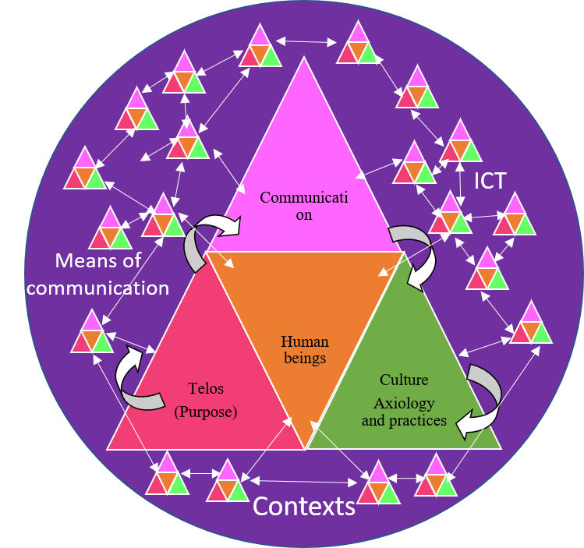
Source: Self Made
Personal mass communication Model
The personal mass communication model (Figure 8), represents a visualization of the complexity that can be created with the nets that are formed through the use of MIM. The interconnections that are produced through the app as an ICT means of communication and technology innovation allow people to be in touch with each other instantly no matter their physical location.
Human beings and their processes are represented as a pyramid whose base is the human being. So physically one moves toward touching the screen and opens a channel of communication with a person or a group of persons with the purpose of exchanging diverse emotional states, depending on their relationship. Also, thinking is involved as one creates a message and interprets the answers given to it through the cultural background they have.
Of course, as a representation this model simplifies reality. Nevertheless, it is important to visualize it with only the purpose of imagining what goes on. There are billions of people who use MIM all over the world (STATISTA, 2019), and the interconnection between them can increase in terms of quantity. These possible interactions between humans represent the complexity -which visualizes reality as integrated by components that interact among each other through a net of feedback cycles (Arras Vota, 2010)- present in every arena of life, including that of communications.

Conclusions
Knowing that a great percentage of people around the world are using ICT on smartphones to be in touch with each other and learn about reality, organizations can use MIM to construct new ways in which they can communicate with personnel and take advantage of the lattice of interaction possibilities to improve organizational climate, in general, and relations among workers in particular, smothering the sense of hierarchy.
Therefore, one could conclude that using these tools that have become a vital part of our daily lives has increased to a more due to the “new normal” which we currently experience because they are a crucial part of social and work life.
Understanding that WA is valued as a fast and easy-to-use personal mass communication means allows groups, companies, and organizations, including MIM applications, to use it as a channel of information to establish contact and send messages that generate direct interpersonal relationships with those groups that they intend to reach.

This only supports the idea that the MIM is quite solid in offering the user of any kind the necessary help to carry out the usual functions in any scenario that may arise, which become essential for the organization's current and future success.

Future Research Lines

It is suggested as future research to continue analyzing the communication process and how it continues to evolve; the reasons that lead people to use this type of instant messaging and thus continue to make the most of its benefits.

References
Alonso, M. H., Bartolomé, J. E. & Bartolomé, A. (2016). Ventajas e inconvenientes del uso de dispositivos electrónicos en el aula: percepción de los estudiantes de grados en comunicación. Revista de Comunicación de la SEECI, 20(41), pp. 136-154.
Andersson, L. & Samuelsson, G. (2019). Understanding the Customer: Examining the Perceived Value of a New Product in a B2B Context, Gothenburg: Chalmers University of Technology.
Arras Vota, A. M. (2010). Comunicación organizacional. (3 ed.). Chihuahua: Doble Hélice.
ATLAS.ti. (2019). All-in-one QDA Software. https://atlasti.com
Baym, N. (2015). Personal connections in the digital age. Cambridge: Polity.
Boyd, D. (2010). Social networking sites as networked publics: Affordances, Dynamics and Implications.In Networked Self: Identity, Community, and Culture on Social Network Sites (ed. Zizi Papacharissi), pp. 39-58.
Caro, M. (2017). Adicciones tecnológicas: ¿Enfermedad o conducta adaptativa?. MediSur, 15(2), pp. 251-260.
Cruz-Cárdemas, J. Guadalupe-Lanas, J., Zabelina, K., Palacio-Fierro, A., Velín-Fárez, M., Waldemar Staniewski, M. (2019). Consumer value creation through WhatsApp use a qualitative multimethod approach in a Latin American scenario. Academia Revista Latinoamericana de Administración, Noviembre, 32(4), pp. 455-471.
Dans, I., González-Sanmamed, M., & Muñoz-Carril, P. C. (2019). Redes sociales, adolescencia y familia: desafíos y oportunidades. Publicaciones, 49(2), 117–132. https://doi.org/10.30827/publicaciones.v49i2.8527.
De Vita Montiel, N. (2008).Tecnologías de información y comunicación para las organizaciones del siglo XXI. Centro de Investigación de ciencias administrativas y gerenciales, 5(1), pp. 77-86.
Dimock, M. (2019). Defining generations: Where Millennials end and Generation Z begins. Pew Research Center, 17 Marzo.pp. 1 - 7.
El Instituto Nacional de Estadística y Geografía (INEGI). (2019). En Mèxico hay 74.3 millones de usuarios de internet y 18.3 millones de hogares con conexion a este servicio: ENDUTIH. Comunicado de prensa nùm. 179/19, 2 April. pp. 1 - 19.
Fondevila-Gascó, J. F., Marqués-Pascual, J., Mir-Bernal, P. & Polo-López, M., 2019. Usos del WhatsApp en el estudiante universitario español. Pros y contras. Revista Latina de Comunicación Social, 74, pp. 308 - 324.
French, M. & Bazarova, N. (2017). Is Anybody Out There?: Understanding Masspersonal Communication Through Expectations for Response Across Social Media Platforms. Journal of Computer-Mediated Communication, 22, p. 303–319.
Google. (2019). Crea formularios atractivos. https://www.google.com/forms/about/?utm_source=gaboutpage&utm_medium=formslink&utm_campaign=gabout
Guitart, M. E., Nadal, J. M. & Vila, I. (2010). La construcciòn narrativa de la identidad en un cotexto educativo intercultural. Revista de Filosofía y Psicología, 5(21), pp. 77-94.

Hartman, R. S. (2011).The Structure of Value: Foundations of Scientific Axiology. Robert Hartman Institute, pp. 1 - 20. https://doi.org/10.1017/S001221730005071X
IBM. (2019). IBM SPSS software. https://www.ibm.com/mx es/analytics/spss-statistics-software
Khurana, P. & Kumar, D. (2018). Sir Model for Fake News Spreading Through Whatsapp. Proceedings of 3rd International Conference on Internet of Things and Connected Technologies , 20 April. pp. 74 -76.
Kluckhohn, C. (1971). Antropologìa. Mèxico: FCE.
Marcus, J. (2011). Apuntes sobre el conceptos de identidad. Revista Sociológica de Pensamiento Crítico, 5(1), pp. 108 - 114.
McLuhan, . M. & Powers, B. R. (1995). La aldea global.. Barcelona: Gedisa.
Montag , C., Błaszkiewicz, K., Sariyska, R., Lachmann, B., Andone, I., Trendafilov , B., Eibes , M., Mark, A. (2015). Smartphone usage in the 21st century: who is active on WhatsApp?. BMC Research Notes, 8, pp. 1 - 6.
Organización para la Cooperación y el Desarrollo Económicos (OECD). (2019). Higher Education in Mexico: Labour Market Relevance and Outcomes, Higher Education , París: OECD Publishing.
Ostle, B. (1980). Estadistica Aplicada. Mexico D.F.: Cientifico Tecnica.
Rivera Sanin, M. L. (2016). Interseccionalidad e inclusión en la educación superior: Consideraciones sobre la Universidad Nacional de Colombia. Pedagogía y Saberes, 44, pp. 105 - 118.
Rivera-Plata, A. (2018). Diseño, identidad e ideología: el diseño como discurso. Pensamiento, palabra y obra, pp. 94 - 103.
Rosenfeld, A., Sina, S., Sarne, D., Avidov, O., Kraus, S. (2018). A Study of WhatsApp Usage Patterns and Prediction Models without Message Content. https://www.researchgate.net/profile/Sarit_Kraus2/publication/323141988_A_Study_of_WhatsApp_Usage_Patterns_and_Prediction_Models_without_Message_Content/links/5a966a0fa6fdccecff0934c5/A-Study-of-WhatsApp-Usage-Patterns-and-Prediction-Models-without-Message-Content.pdf
Rubio Romero, J. & Perlado Lamo de Espinosa, M. (2015). El fenomeno WhatsApp en el contexto de la comunicacion personal: una aproximacion a través de los jóvenes universitarios. ICONO14 Revista Científica de Comunicación y Tecnologías Emergentes, 13(2), pp. 73-94.
Sankalp, R. C., Mohmmed, I. H. & Kantharia, S. L. (2015). Facebook and WA: Beneficial or Harmful?. Journal of evidence based Medicine and Healthcare, 2(17), pp. 2506-2511.
Shahin, A. I. (2019). Cultural Issues in Communication Technology an Egyptian Perspective. The International Journal of Business Management and Technology, 3(4), pp. 61 - 72.
STATISTA. (2019). Ranking de las principales redes sociales a nivel mundial según el número de usuarios activos en abril de 2019 (en millones).
https://es.statista.com/estadisticas/600712/ranking-mundial-de-redes-sociales-por-numero-de-usuarios/
STATISTA a. (2020). Redes sociales con el mayor porcentaje de usuarios en Mèxico en 2019. https://es.statista.com/estadisticas/1035031/mexico-porcentaje-de-usuarios-por-red-social/
STATISTA b. (2020). México: población total desde 2014 hasta 2024.
https://es.statista.com/estadisticas/635250/poblacion-total-de-mexico-en-2020/
Velarde, O., Bernete, F. & Casas-Más, B. (2019). Las interacciones virtuales con personas conocidas que no son amigas. Revista Latina de Comunicación Social, 74, pp. 668 - 691.
Vidales-Bolaño, M.-J. & Sádaba-Chalezquer, C. (2017). Adolescentes contectados: La medición del impacto del móvil en las relaciones sociales desde el capital social. Comunicar, XXV 53, 4º trimestre(53), pp. 19 - 28.
WhatsApp Inc. a. (2019). Mensajeria Confiable. Simple. Segura. https://www.whatsapp.com/
WhatsApp Inc. b. (2019). Whatsapp Web. https://web.whatsapp.com/

Rol de Contribución | Autor(es)
Conceptualización | José Luis Bordas Beltrán – igual  Ana María De Guadalupe Arras Vota - igual  Damian Aaron Porras Flores - igual  María Del Carmen Gutiérrez Diez - igual
Metodología | Ana María De Guadalupe Arras Vota
Análisis Formal | José Luis Bordas Beltrán
Investigación | José Luis Bordas Beltrán – igual  Ana María De Guadalupe Arras Vota - igual  Damian Aaron Porras Flores - igual  María Del Carmen Gutiérrez Diez - igual
Recursos | Damian Aaron Porras Flores - principal  María Del Carmen Gutiérrez Diez - apoyo
Curación de datos | José Luis Bordas Beltrán – igual  Ana María De Guadalupe Arras Vota - igual  Damian Aaron Porras Flores - igual  María Del Carmen Gutiérrez Diez - igual
Escritura - Preparación del borrador original | Ana María De Guadalupe Arras Vota - principal  José Luis Bordas Beltrán - apoyo
Escritura - Revisión y edición | Ana María De Guadalupe Arras Vota - igual  José Luis Bordas Beltrán - igual
Visualización | José Luis Bordas Beltrán – igual  Ana María De Guadalupe Arras Vota - igual  Damian Aaron Porras Flores - igual  María Del Carmen Gutiérrez Diez - igual
Supervisión | Ana María De Guadalupe Arras Vota
Administración de Proyectos | José Luis Bordas Beltrán
Adquisición de fondos | Damian Aaron Porras Flores

